**CHAPTER 4**

**Training Models**



With Early Release ebooks, you get books in their earliest form— the author’s raw and unedited content as he or she writes—so you can take advantage of these technologies long before the official release of these titles. The following will be Chapter 4 in the final release of the book.



So far we have treated Machine Learning models and their training algorithms mostly like black boxes. If you went through some of the exercises in the previous chapters, you may have been surprised by how much you can get done without knowing any‐ thing about what’s under the hood: you optimized a regression system, you improved a digit image classifier, and you even built a spam classifier from scratch—all this without knowing how they actually work. Indeed, in many situations you don’t really need to know the implementation details.

However, having a good understanding of how things work can help you quickly home in on the appropriate model, the right training algorithm to use, and a good set of hyperparameters for your task. Understanding what’s under the hood will also help you debug issues and perform error analysis more efficiently. Lastly, most of the top‐ ics discussed in this chapter will be essential in understanding, building, and training neural networks (discussed in Part II of this book).

In this chapter, we will start by looking at the Linear Regression model, one of the simplest models there is. We will discuss two very different ways to train it:

* Using a direct “closed-form” equation that directly computes the model parame‐ ters that best fit the model to the training set (i.e., the model parameters that minimize the cost function over the training set).



**113**

* Using an iterative optimization approach, called Gradient Descent (GD), that gradually tweaks the model parameters to minimize the cost function over the training set, eventually converging to the same set of parameters as the first method. We will look at a few variants of Gradient Descent that we will use again and again when we study neural networks in Part II: Batch GD, Mini-batch GD, and Stochastic GD.

Next we will look at Polynomial Regression, a more complex model that can fit non‐ linear datasets. Since this model has more parameters than Linear Regression, it is more prone to overfitting the training data, so we will look at how to detect whether or not this is the case, using learning curves, and then we will look at several regulari‐ zation techniques that can reduce the risk of overfitting the training set.

Finally, we will look at two more models that are commonly used for classification tasks: Logistic Regression and Softmax Regression.

There will be quite a few math equations in this chapter, using basic notions of linear algebra and calculus. To understand these equa‐ tions, you will need to know what vectors and matrices are, how to transpose them, multiply them, and inverse them, and what partial derivatives are. If you are unfamiliar with these concepts, please go through the linear algebra and calculus introductory tutorials avail‐ able as Jupyter notebooks in the online supplemental material. For those who are truly allergic to mathematics, you should still go through this chapter and simply skip the equations; hopefully, the text will be sufficient to help you understand most of the concepts.



**Linear Regression**

In Chapter 1, we looked at a simple regression model of life satisfaction: *life_satisfac‐* *tion* = *θ*0+ *θ*1× *GDP_per_capita*.

This model is just a linear function of the input feature GDP_per_capita. *θ*0 and *θ*1 are the model’s parameters.

More generally, a linear model makes a prediction by simply computing a weighted sum of the input features, plus a constant called the *bias term* (also called the *intercept* *term*), as shown inEquation 4-1.

*Equation 4-1. Linear Regression model prediction*

* 1. = *θ*0 + *θ*1*x*1 + *θ*2*x*2 + ⋯ + *θnxn*
* *ŷ* is the predicted value.



**114** **|** **Chapter 4: Training Models**

* *n* is the number of features.
* *x*iis the ithfeature value.
* *θj* is the jthmodel parameter (including the bias term *θ*0and the feature weights *θ*1, *θ*2,⋯, *θn*).

This can be written much more concisely using a vectorized form, as shown in Equa‐ tion 4-2.

*Equation 4-2. Linear Regression model prediction (vectorized form)*

* 1. = *h***θ******x**** = **θ** · **x**
* **θ** is the model’s*parameter vector*, containing the bias term*θ*0and the featureweights *θ*1 to *θ*n.
* **x** is the instance’s*feature vector*, containing*x*0to*xn*, with*x*0always equal to 1.
* **θ** · **x** is the dot product of the vectors **θ** and **x**, which is of course equal to

*θ*0*x*0+ *θ*1*x*1+ *θ*2*x*2+⋯+ *θnxn*.

* *h***θ**is the hypothesis function, using the model parameters**θ**.

In Machine Learning, vectors are often represented as *column vec‐* *tors*, which are 2D arrays with a single column. If**θ**and**x**are col‐



umn vectors, then the prediction is: *y* = **θTx**, where **θT** is the *transpose* of**θ**(a row vector instead of a column vector) and**θTx**is

the matrix multiplication of **θT** and **x**. It is of course the same pre‐ diction, except it is now represented as a single cell matrix rather than a scalar value. In this book we will use this notation to avoid switching between dot products and matrix multiplications.

Okay, that’s the Linear Regression model, so now how do we train it? Well, recall that training a model means setting its parameters so that the model best fits the training set. For this purpose, we first need a measure of how well (or poorly) the model fits the training data. In Chapter 2 we saw that the most common performance measure of a regression model is the Root Mean Square Error (RMSE) (Equation 2-1). There‐ fore, to train a Linear Regression model, you need to find the value of **θ** that minimi‐ zes the RMSE. In practice, it is simpler to minimize the Mean Square Error (MSE)



**Linear Regression** **|** **115**

than the RMSE, and it leads to the same result (because the value that minimizes a function also minimizes its square root).1

The MSE of a Linear Regression hypothesis *h***θ** on a training set **X** is calculated using Equation 4-3.

*Equation 4-3. MSE cost function for a Linear Regression model*

|  |  |  |  |  |  |  |
| --- | --- | --- | --- | --- | --- | --- |
|  |  | 1 | *m* |  | 2 |  |
| MSE **X**, *h***θ** | = | ∑ | **θ***T***x** *i*−*y**i* |  |
|  |  |  |
|  |  | *m i* = 1 | | |  |  |

Most of these notations were presented in Chapter 2 (see “Notations” on page 43). The only difference is that we write *h***θ** instead of just *h* in order to make it clear that the model is parametrized by the vector **θ**. To simplify notations, we will just write MSE(**θ**) instead of MSE(**X**, *h***θ**).

**The Normal Equation**

To find the value of **θ** that minimizes the cost function, there is a *closed-form solution* —in other words, a mathematical equation that gives the result directly. This is called the *Normal Equation* (Equation 4-4).2

*Equation 4-4. Normal Equation*

**θ** = **X***T***X**−1 **X***T* **y**



* **θ** is the value of **θ** that minimizes the cost function.
* **y** is the vector of target values containing*y*(1)to*y*(*m*).

Let’s generate some linear-looking data to test this equation on (Figure 4-1):

**import numpy as np**

X = 2 * np.random.rand(100, 1)

y = 4 + 3 * X + np.random.randn(100, 1)



1. It is often the case that a learning algorithm will try to optimize a different function than the performance measure used to evaluate the final model. This is generally because that function is easier to compute, because it has useful differentiation properties that the performance measure lacks, or because we want to constrain the model during training, as we will see when we discuss regularization.
2. The demonstration that this returns the value of **θ** that minimizes the cost function is outside the scope of this book.



**116** **|** **Chapter 4: Training Models**

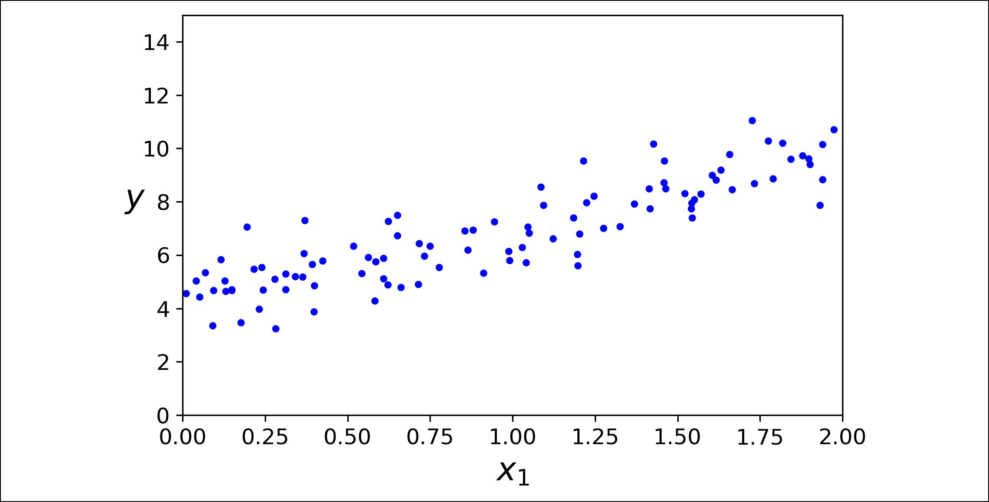

*Figure 4-1. Randomly generated linear dataset*



Now let’s compute **θ** using the Normal Equation. We will use the inv() function from NumPy’s Linear Algebra module (np.linalg) to compute the inverse of a matrix, and the dot() method for matrix multiplication:

X_b = np.c_[np.ones((100, 1)), X] *# add x0 = 1 to each instance* theta_best = np.linalg.inv(X_b.T.dot(X_b)).dot(X_b.T).dot(y)

The actual function that we used to generate the data is *y* = 4 + 3*x*1 + Gaussian noise. Let’s see what the equation found:

**>>>** theta_bestarray([[4.21509616],

[2.77011339]])

We would have hoped for *θ*0 = 4 and *θ*1 = 3 instead of *θ*0 = 4.215 and *θ*1 = 2.770. Close enough, but the noise made it impossible to recover the exact parameters of the origi‐ nal function.



Now you can make predictions using **θ**:

* X_new = np.array([[0], [2]])
* X_new_b = np.c_[np.ones((2, 1)), X_new] *# add x0 = 1 to each instance*
* y_predict = X_new_b.dot(theta_best)
* y_predict

array([[4.21509616],

[9.75532293]])

Let’s plot this model’s predictions (Figure 4-2):

plt.plot(X_new, y_predict, "r-") plt.plot(X, y, "b.")



**Linear Regression** **|** **117**

plt.axis([0, 2, 0, 15]) plt.show()

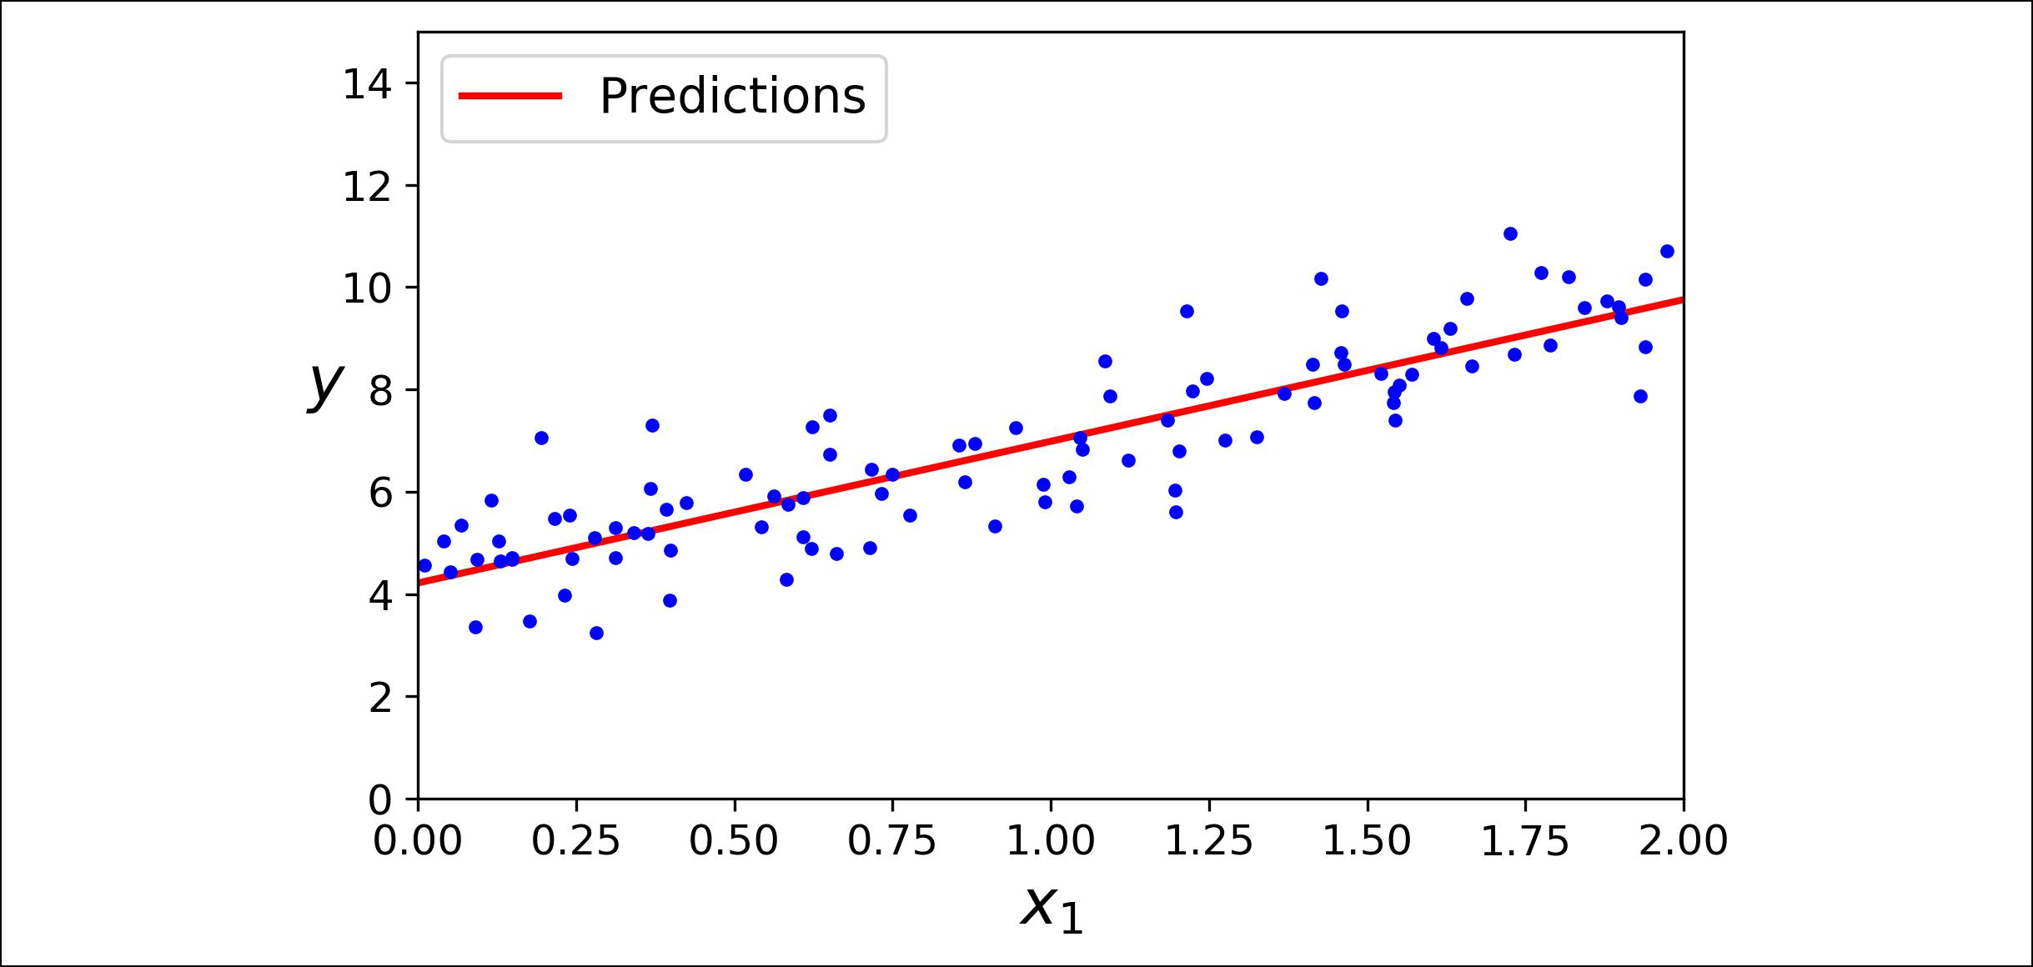

*Figure 4-2. Linear Regression model predictions*

Performing linear regression using Scikit-Learn is quite simple:3

* **from sklearn.linear_model import** LinearRegression
* lin_reg = LinearRegression()
* lin_reg.fit(X, y)
* lin_reg.intercept_, lin_reg.coef_ (array([4.21509616]), array([[2.77011339]]))
* lin_reg.predict(X_new)

array([[4.21509616],

[9.75532293]])

The LinearRegression class is based on the scipy.linalg.lstsq() function (the name stands for “least squares”), which you could call directly:

* theta_best_svd, residuals, rank, s = np.linalg.lstsq(X_b, y, rcond=1e-6)
* theta_best_svd

array([[4.21509616],

[2.77011339]])

This function computes **θ** = **X**+**y**, where + is the *pseudoinverse* of **X** (specifically the Moore-Penrose inverse). You can use np.linalg.pinv() to compute the pseudoin‐ verse directly:



**>>>** np.linalg.pinv(X_b).dot(y)array([[4.21509616],

[2.77011339]])



3 Note that Scikit-Learn separates the bias term (intercept_) from the feature weights (coef_).



**118** **|** **Chapter 4: Training Models**

The pseudoinverse itself is computed using a standard matrix factorization technique called *Singular Value Decomposition* (SVD) that can decompose the training set matrix **X** into the matrix multiplication of three matrices **U Σ V***T* (see

numpy.linalg.svd()). The pseudoinverse is computed as **X**+ = **VΣ**+**U**T. To compute

the matrix **Σ**+, the algorithm takes **Σ** and sets to zero all values smaller than a tiny threshold value, then it replaces all the non-zero values with their inverse, and finally it transposes the resulting matrix. This approach is more efficient than computing the Normal Equation, plus it handles edge cases nicely: indeed, the Normal Equation may not work if the matrix **X**T**X** is not invertible (i.e., singular), such as if *m* < *n* or if some features are redundant, but the pseudoinverse is always defined.

**Computational Complexity**

The Normal Equation computes the inverse of **X***T* **X**, which is an (*n* + 1) × (*n* + 1) matrix (where *n* is the number of features). The *computational complexity* of inverting such a matrix is typically about *O*(*n*2.4) to *O*(*n*3) (depending on the implementation). In other words, if you double the number of features, you multiply the computation time by roughly 22.4 = 5.3 to 23 = 8.

The SVD approach used by Scikit-Learn’s LinearRegression class is about *O*(*n*2). If you double the number of features, you multiply the computation time by roughly 4.

Both the Normal Equation and the SVD approach get very slow when the number of features grows large (e.g., 100,000). On the positive side, both are linear with regards to the number of instan‐ ces in the training set (they are *O*(*m*)), so they handle large training sets efficiently, provided they can fit in memory.



Also, once you have trained your Linear Regression model (using the Normal Equa‐ tion or any other algorithm), predictions are very fast: the computational complexity is linear with regards to both the number of instances you want to make predictions on and the number of features. In other words, making predictions on twice as many instances (or twice as many features) will just take roughly twice as much time.

Now we will look at very different ways to train a Linear Regression model, better suited for cases where there are a large number of features, or too many training instances to fit in memory.

**Gradient Descent**

*Gradient Descent* is a very generic optimization algorithm capable of finding optimalsolutions to a wide range of problems. The general idea of Gradient Descent is to tweak parameters iteratively in order to minimize a cost function.



**Gradient Descent** **|** **119**

Suppose you are lost in the mountains in a dense fog; you can only feel the slope of the ground below your feet. A good strategy to get to the bottom of the valley quickly is to go downhill in the direction of the steepest slope. This is exactly what Gradient Descent does: it measures the local gradient of the error function with regards to the parameter vector **θ**, and it goes in the direction of descending gradient. Once the gra‐ dient is zero, you have reached a minimum!

Concretely, you start by filling **θ** with random values (this is called *random initializa‐* *tion*), and then you improve it gradually, taking one baby step at a time, each stepattempting to decrease the cost function (e.g., the MSE), until the algorithm *converges* to a minimum (see Figure 4-3).

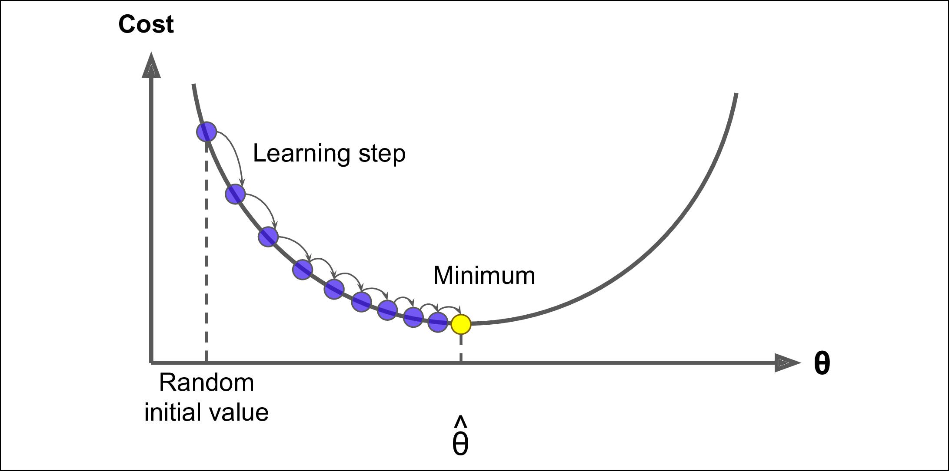

*Figure 4-3. Gradient Descent*

An important parameter in Gradient Descent is the size of the steps, determined by the *learning rate* hyperparameter. If the learning rate is too small, then the algorithm will have to go through many iterations to converge, which will take a long time (see Figure 4-4).



**120** **|** **Chapter 4: Training Models**

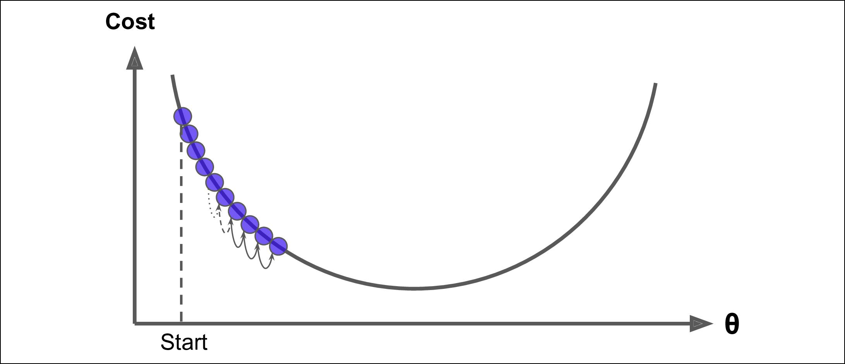

*Figure 4-4. Learning rate too small*

On the other hand, if the learning rate is too high, you might jump across the valley and end up on the other side, possibly even higher up than you were before. This might make the algorithm diverge, with larger and larger values, failing to find a good solution (see Figure 4-5).

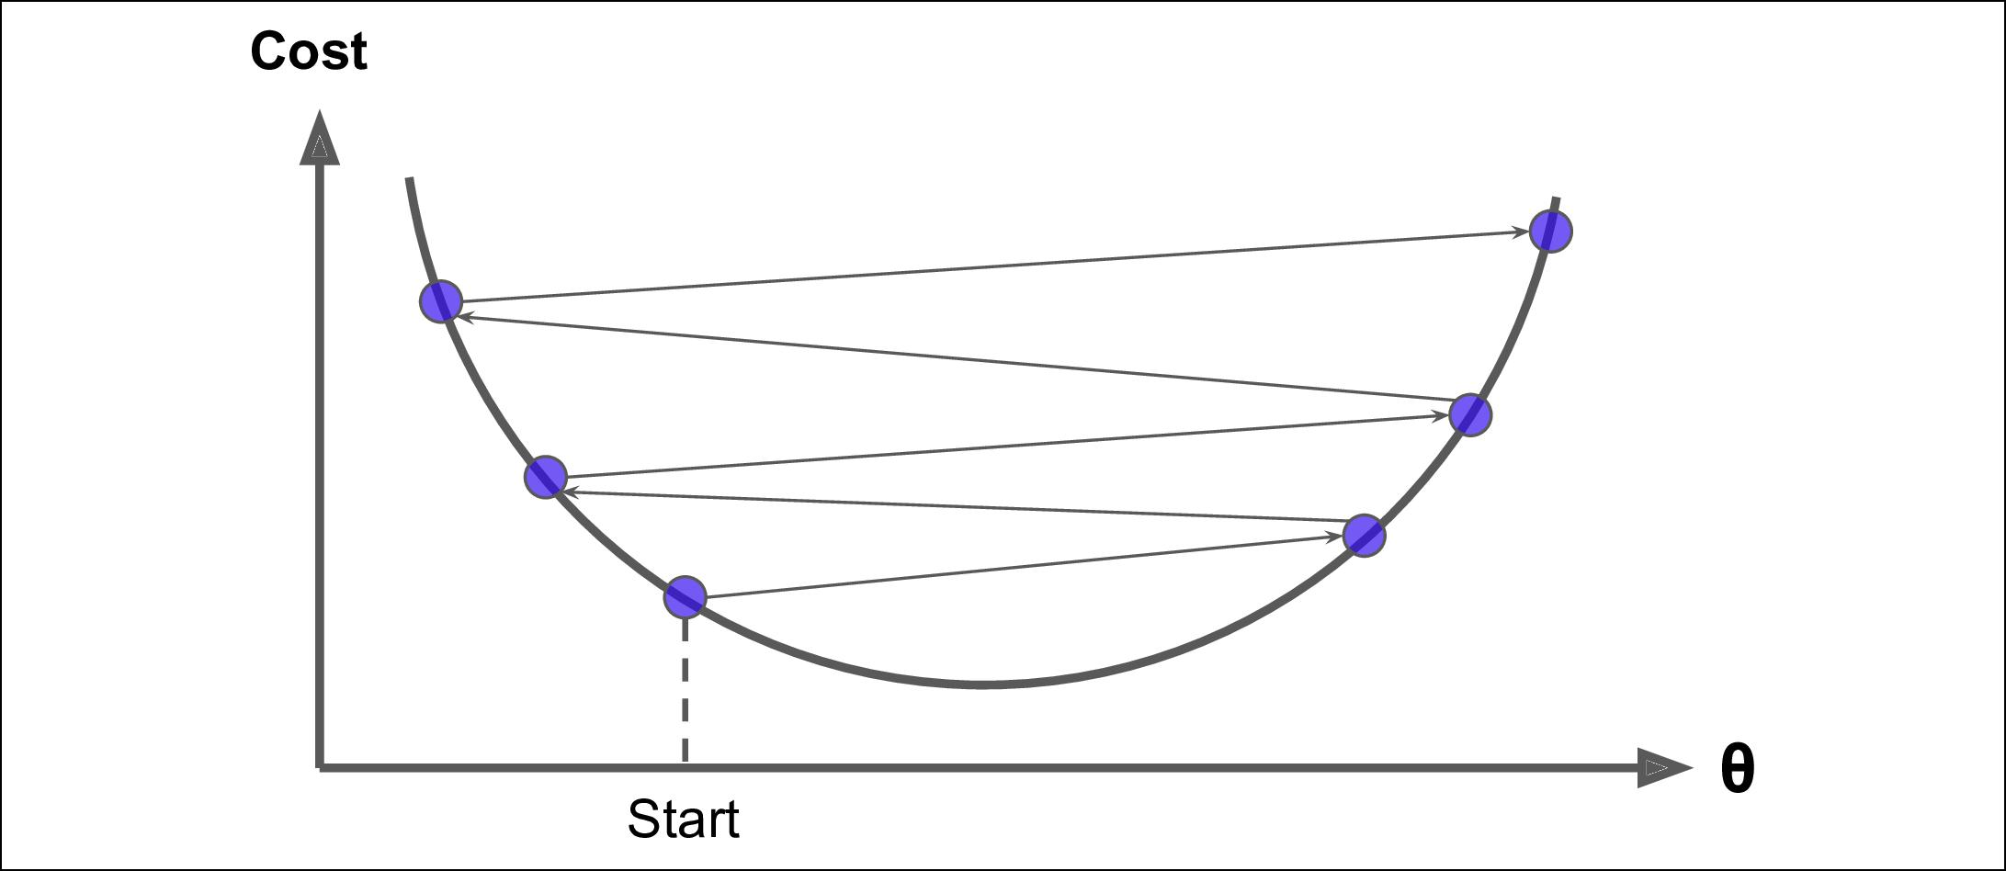

*Figure 4-5. Learning rate too large*

Finally, not all cost functions look like nice regular bowls. There may be holes, ridges, plateaus, and all sorts of irregular terrains, making convergence to the minimum very difficult. Figure 4-6 shows the two main challenges with Gradient Descent: if the ran‐ dom initialization starts the algorithm on the left, then it will converge to a *local mini‐* *mum*, which is not as good as the *global minimum*. If it starts on the right, then it willtake a very long time to cross the plateau, and if you stop too early you will never reach the global minimum.



**Gradient Descent** **|** **121**

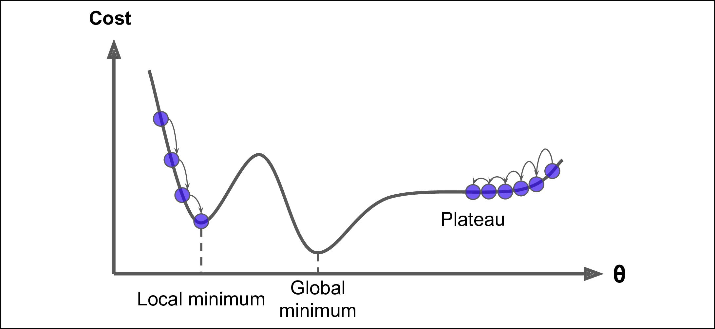

*Figure 4-6. Gradient Descent pitfalls*

Fortunately, the MSE cost function for a Linear Regression model happens to be a *convex function*, which means that if you pick any two points on the curve, the linesegment joining them never crosses the curve. This implies that there are no local minima, just one global minimum. It is also a continuous function with a slope that never changes abruptly.4 These two facts have a great consequence: Gradient Descent is guaranteed to approach arbitrarily close the global minimum (if you wait long enough and if the learning rate is not too high).

In fact, the cost function has the shape of a bowl, but it can be an elongated bowl if the features have very different scales. Figure 4-7 shows Gradient Descent on a train‐ ing set where features 1 and 2 have the same scale (on the left), and on a training set where feature 1 has much smaller values than feature 2 (on the right).5

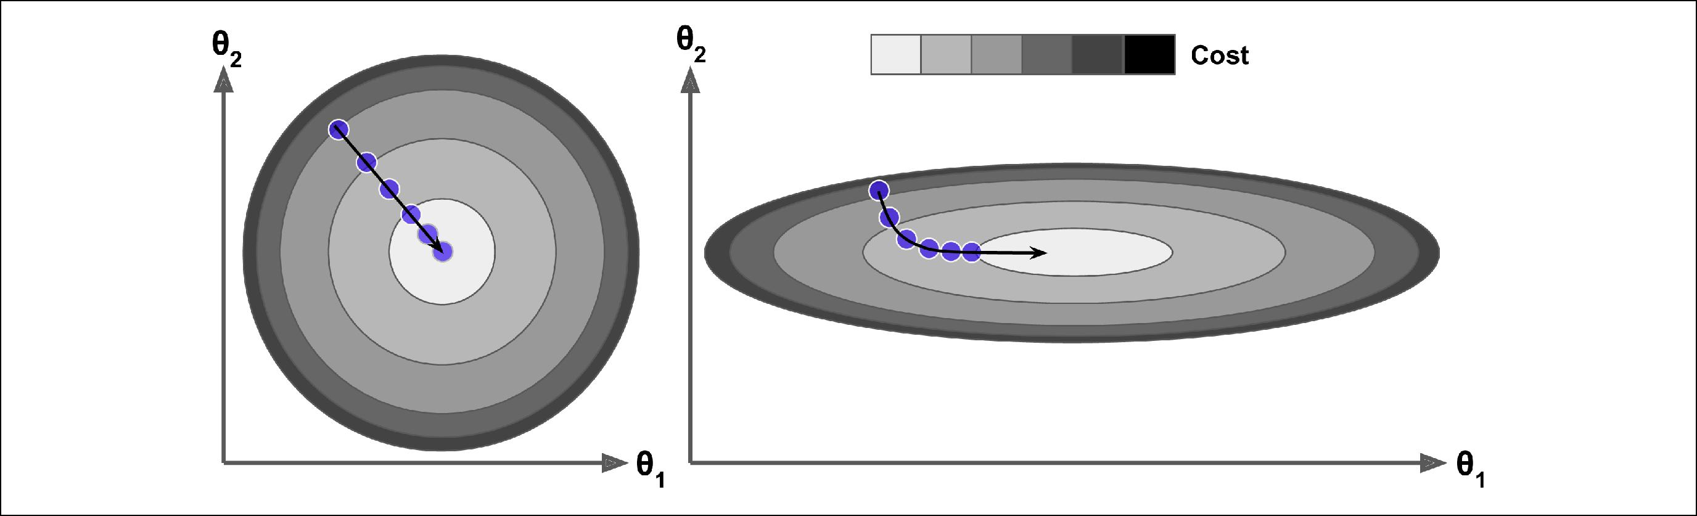

*Figure 4-7. Gradient Descent with and without feature scaling*



1. Technically speaking, its derivative is *Lipschitz continuous*.
2. Since feature 1 is smaller, it takes a larger change in *θ*1 to affect the cost function, which is why the bowl is elongated along the *θ*1 axis.



**122** **|** **Chapter 4: Training Models**

As you can see, on the left the Gradient Descent algorithm goes straight toward the minimum, thereby reaching it quickly, whereas on the right it first goes in a direction almost orthogonal to the direction of the global minimum, and it ends with a long march down an almost flat valley. It will eventually reach the minimum, but it will take a long time.

When using Gradient Descent, you should ensure that all features have a similar scale (e.g., using Scikit-Learn’s StandardScaler class), or else it will take much longer to converge.



This diagram also illustrates the fact that training a model means searching for a combination of model parameters that minimizes a cost function (over the training set). It is a search in the model’s *parameter space*: the more parameters a model has, the more dimensions this space has, and the harder the search is: searching for a nee‐ dle in a 300-dimensional haystack is much trickier than in three dimensions. Fortu‐ nately, since the cost function is convex in the case of Linear Regression, the needle is simply at the bottom of the bowl.

**Batch Gradient Descent**

To implement Gradient Descent, you need to compute the gradient of the cost func‐ tion with regards to each model parameter *θj*. In other words, you need to calculate how much the cost function will change if you change *θj* just a little bit. This is called a *partial derivative*. It is like asking “what is the slope of the mountain under my feet if I face east?” and then asking the same question facing north (and so on for all other dimensions, if you can imagine a universe with more than three dimensions). Equa‐ tion 4-5 computes the partial derivative of the cost function with regards to parame‐

ter *θj*, noted ∂∂*θj* MSE(**θ**).

*Equation 4-5. Partial derivatives of the cost function*

|  |  |  |  |  |  |  |  |  |
| --- | --- | --- | --- | --- | --- | --- | --- | --- |
| ∂ |  |  | 2 | *m* |  |  |  |  |
| MSE **θ** | = | ∑ | **θ***T***x** *i* | − *y* *i* | *xji* |  |
|  |  |  |
| ∂*θj* | |  | *m i* = 1 | | |  |  |  |

Instead of computing these partial derivatives individually, you can use Equation 4-6 to compute them all in one go. The gradient vector, noted ∇**θ**MSE(**θ**), contains all the partial derivatives of the cost function (one for each model parameter).



**Gradient Descent** **|** **123**

*Equation 4-6. Gradient vector of the cost function*

|  |  |  |  |  |  |  |  |  |  |
| --- | --- | --- | --- | --- | --- | --- | --- | --- | --- |
|  |  |  |  | ∂ |  | MSE **θ** |  |  |  |
|  |  |  |  | ∂*θ*0 |  |  |  |
|  |  |  |  |  |  |  |  |  |
|  |  |  |  | ∂ |  | MSE **θ** = | 2 | **X***T* **Xθ** − **y** |  |
| ∇ | **θ** | MSE **θ** = | | ∂*θ*1 |  |  |
|  |  |  |
|  |  |  |  |  | ⋮ | *m* | |  |
|  |  |  |  |  |  |  |  |  |
|  |  |  |  | ∂ |  | MSE **θ** |  |  |  |
|  |  |  |  | ∂*θ* |  |  |  |  |
|  |  |  |  | *n* |  |  |  |  |  |



Notice that this formula involves calculations over the full training set **X**, at each Gradient Descent step! This is why the algorithm is called *Batch Gradient Descent*: it uses the whole batch of training data at every step (actually, *Full Gradient Descent* would probably be a better name). As a result it is terribly slow on very large train‐ ing sets (but we will see much faster Gradient Descent algorithms shortly). However, Gradient Descent scales well with the number of features; training a Linear Regression model when there are hun‐ dreds of thousands of features is much faster using Gradient Descent than using the Normal Equation or SVD decomposition.



Once you have the gradient vector, which points uphill, just go in the opposite direc‐ tion to go downhill. This means subtracting ∇**θ**MSE(**θ**) from **θ**. This is where the learning rate *η* comes into play:6 multiply the gradient vector by *η* to determine the size of the downhill step (Equation 4-7).

*Equation 4-7. Gradient Descent step*

**θ**next step = **θ** − *η* ∇**θ** MSE**θ**

Let’s look at a quick implementation of this algorithm:

eta = 0.1 *# learning rate* n_iterations = 1000

m = 100

theta = np.random.randn(2,1) *# random initialization*

**for** iteration **in** range(n_iterations):

gradients = 2/m * X_b.T.dot(X_b.dot(theta) - y) theta = theta - eta * gradients



6 Eta (*η*) is the 7th letter of the Greek alphabet.



**124** **|** **Chapter 4: Training Models**

That wasn’t too hard! Let’s look at the resulting theta:

**>>>** thetaarray([[4.21509616],

[2.77011339]])

Hey, that’s exactly what the Normal Equation found! Gradient Descent worked per‐ fectly. But what if you had used a different learning rate eta? Figure 4-8 shows the first 10 steps of Gradient Descent using three different learning rates (the dashed line represents the starting point).

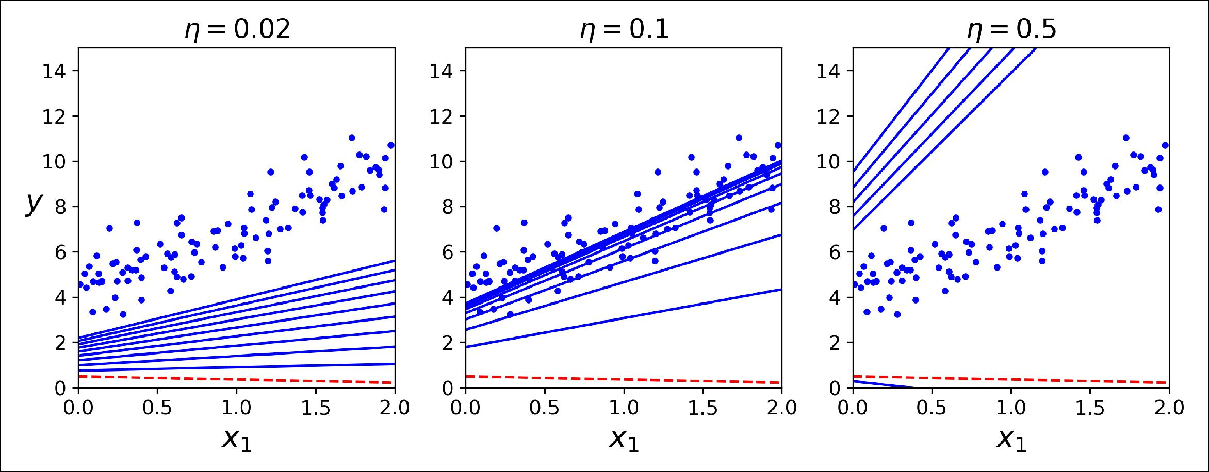

*Figure 4-8. Gradient Descent with various learning rates*

On the left, the learning rate is too low: the algorithm will eventually reach the solu‐ tion, but it will take a long time. In the middle, the learning rate looks pretty good: in just a few iterations, it has already converged to the solution. On the right, the learn‐ ing rate is too high: the algorithm diverges, jumping all over the place and actually getting further and further away from the solution at every step.

To find a good learning rate, you can use grid search (see Chapter 2). However, you may want to limit the number of iterations so that grid search can eliminate models that take too long to converge.

You may wonder how to set the number of iterations. If it is too low, you will still be far away from the optimal solution when the algorithm stops, but if it is too high, you will waste time while the model parameters do not change anymore. A simple solu‐ tion is to set a very large number of iterations but to interrupt the algorithm when the gradient vector becomes tiny—that is, when its norm becomes smaller than a tiny number *ϵ* (called the *tolerance*)—because this happens when Gradient Descent has (almost) reached the minimum.



**Gradient Descent** **|** **125**

**Convergence Rate**

When the cost function is convex and its slope does not change abruptly (as is the case for the MSE cost function), Batch Gradient Descent with a fixed learning rate will eventually converge to the optimal solution, but you may have to wait a while: it can take O(1/*ϵ*) iterations to reach the optimum within a range of *ϵ* depending on the shape of the cost function. If you divide the tolerance by 10 to have a more precise solution, then the algorithm may have to run about 10 times longer.

**Stochastic Gradient Descent**

The main problem with Batch Gradient Descent is the fact that it uses the whole training set to compute the gradients at every step, which makes it very slow when the training set is large. At the opposite extreme, *Stochastic Gradient Descent* just picks a random instance in the training set at every step and computes the gradients based only on that single instance. Obviously this makes the algorithm much faster since it has very little data to manipulate at every iteration. It also makes it possible to train on huge training sets, since only one instance needs to be in memory at each iteration (SGD can be implemented as an out-of-core algorithm.7)

On the other hand, due to its stochastic (i.e., random) nature, this algorithm is much less regular than Batch Gradient Descent: instead of gently decreasing until it reaches the minimum, the cost function will bounce up and down, decreasing only on aver‐ age. Over time it will end up very close to the minimum, but once it gets there it will continue to bounce around, never settling down (see Figure 4-9). So once the algo‐ rithm stops, the final parameter values are good, but not optimal.

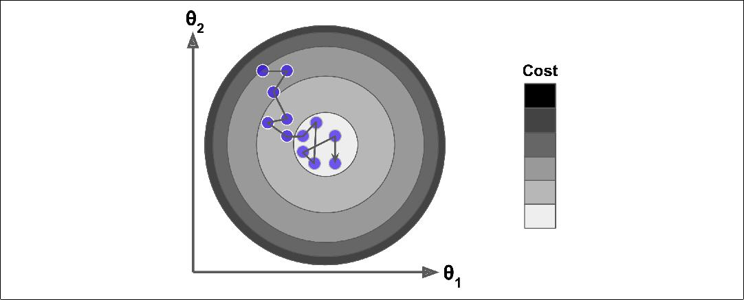

*Figure 4-9. Stochastic Gradient Descent*



7 Out-of-core algorithms are discussed in Chapter 1.



**126** **|** **Chapter 4: Training Models**

When the cost function is very irregular (as in Figure 4-6), this can actually help the algorithm jump out of local minima, so Stochastic Gradient Descent has a better chance of finding the global minimum than Batch Gradient Descent does.

Therefore randomness is good to escape from local optima, but bad because it means that the algorithm can never settle at the minimum. One solution to this dilemma is to gradually reduce the learning rate. The steps start out large (which helps make quick progress and escape local minima), then get smaller and smaller, allowing the algorithm to settle at the global minimum. This process is akin to *simulated anneal‐* *ing*, an algorithm inspired from the process of annealing in metallurgy where moltenmetal is slowly cooled down. The function that determines the learning rate at each iteration is called the *learning schedule*. If the learning rate is reduced too quickly, you may get stuck in a local minimum, or even end up frozen halfway to the minimum. If the learning rate is reduced too slowly, you may jump around the minimum for a long time and end up with a suboptimal solution if you halt training too early.

This code implements Stochastic Gradient Descent using a simple learning schedule:

n_epochs = 50

t0, t1 = 5, 50 *# learning schedule hyperparameters*

**def** learning_schedule(t): **return** t0/(t+t1)

theta = np.random.randn(2,1) *# random initialization*

**for** epoch **in** range(n_epochs): **for** i **in** range(m):

random_index = np.random.randint(m) xi = X_b[random_index:random_index+1] yi = y[random_index:random_index+1]

gradients = 2 * xi.T.dot(xi.dot(theta) - yi) eta = learning_schedule(epoch * m + i) theta = theta - eta * gradients

By convention we iterate by rounds of *m* iterations; each round is called an *epoch*. While the Batch Gradient Descent code iterated 1,000 times through the whole train‐ ing set, this code goes through the training set only 50 times and reaches a fairly good solution:

**>>>** thetaarray([[4.21076011],

[2.74856079]])

Figure 4-10 shows the first 20 steps of training (notice how irregular the steps are).



**Gradient Descent** **|** **127**

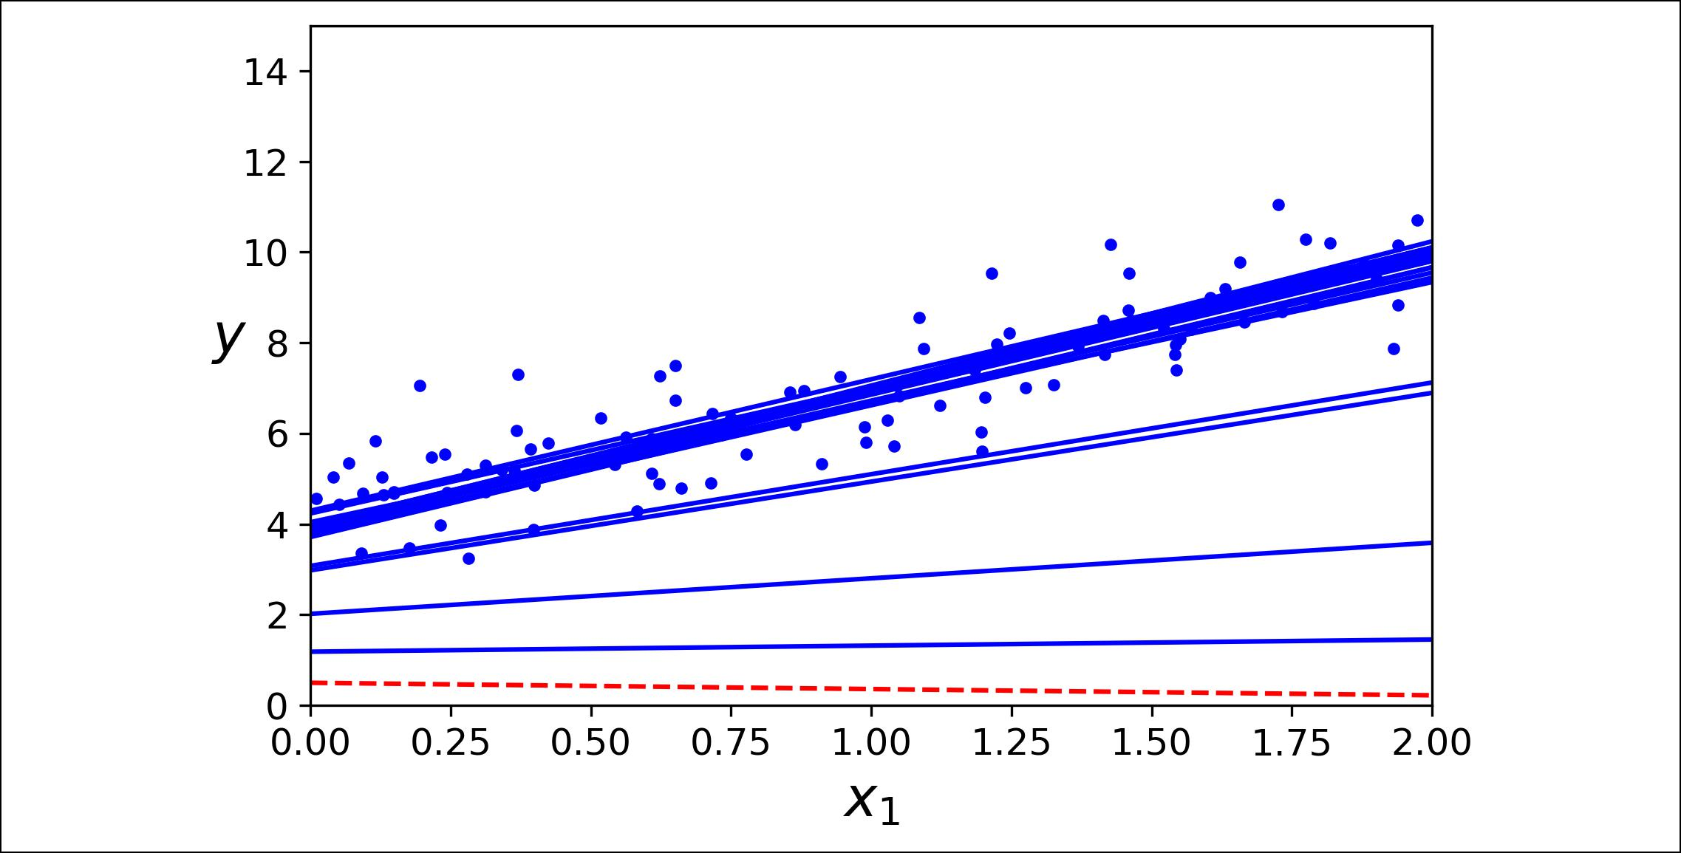

*Figure 4-10. Stochastic Gradient Descent first 20 steps*

Note that since instances are picked randomly, some instances may be picked several times per epoch while others may not be picked at all. If you want to be sure that the algorithm goes through every instance at each epoch, another approach is to shuffle the training set (making sure to shuffle the input features and the labels jointly), then go through it instance by instance, then shuffle it again, and so on. However, this gen‐ erally converges more slowly.

When using Stochastic Gradient Descent, the training instances must be independent and identically distributed (IID), to ensure that the parameters get pulled towards the global optimum, on average. A simple way to ensure this is to shuffle the instances dur‐ ing training (e.g., pick each instance randomly, or shuffle the train‐ ing set at the beginning of each epoch). If you do not do this, for example if the instances are sorted by label, then SGD will start by optimizing for one label, then the next, and so on, and it will not settle close to the global minimum.



To perform Linear Regression using SGD with Scikit-Learn, you can use the SGDRe gressor class, which defaults to optimizing the squared error cost function. The fol‐ lowing code runs for maximum 1000 epochs (max_iter=1000) or until the loss drops by less than 1e-3 during one epoch (tol=1e-3), starting with a learning rate of 0.1 (eta0=0.1), using the default learning schedule (different from the preceding one), and it does not use any regularization (penalty=None; more details on this shortly):

**from sklearn.linear_model import** SGDRegressor

sgd_reg = SGDRegressor(max_iter=1000, tol=1e-3, penalty=None, eta0=0.1) sgd_reg.fit(X, y.ravel())



**128** **|** **Chapter 4: Training Models**

Once again, you find a solution quite close to the one returned by the Normal Equa‐ tion:

**>>>** sgd_reg.intercept_,sgd_reg.coef_(array([4.24365286]), array([2.8250878]))

**Mini-batch Gradient Descent**

The last Gradient Descent algorithm we will look at is called *Mini-batch Gradient* *Descent*. It is quite simple to understand once you know Batch and Stochastic Gradi‐ent Descent: at each step, instead of computing the gradients based on the full train‐ ing set (as in Batch GD) or based on just one instance (as in Stochastic GD), Mini-batch GD computes the gradients on small random sets of instances called *mini-batches*. The main advantage of Mini-batch GD over Stochastic GD is that you canget a performance boost from hardware optimization of matrix operations, especially when using GPUs.

The algorithm’s progress in parameter space is less erratic than with SGD, especially with fairly large mini-batches. As a result, Mini-batch GD will end up walking around a bit closer to the minimum than SGD. But, on the other hand, it may be harder for it to escape from local minima (in the case of problems that suffer from local minima, unlike Linear Regression as we saw earlier). Figure 4-11 shows the paths taken by the three Gradient Descent algorithms in parameter space during training. They all end up near the minimum, but Batch GD’s path actually stops at the minimum, while both Stochastic GD and Mini-batch GD continue to walk around. However, don’t forget that Batch GD takes a lot of time to take each step, and Stochas‐ tic GD and Mini-batch GD would also reach the minimum if you used a good learn‐ ing schedule.

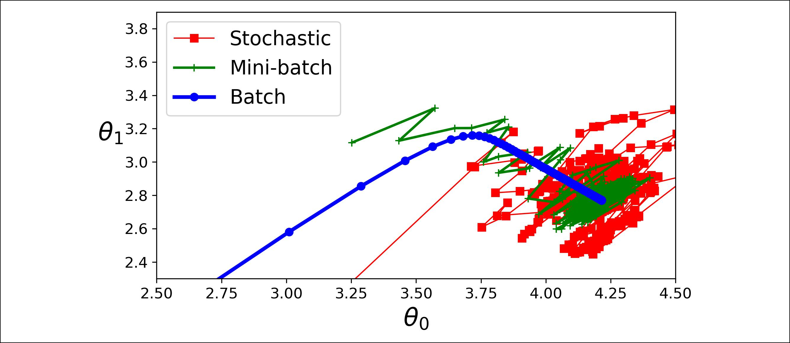

*Figure 4-11. Gradient Descent paths in parameter space*



**Gradient Descent** **|** **129**

Let’s compare the algorithms we’ve discussed so far for Linear Regression8 (recall that *m* is the number of training instances and *n* is the number of features); seeTable 4-1.

*Table 4-1. Comparison of algorithms for Linear Regression*

|  |  |  |  |  |  |  |
| --- | --- | --- | --- | --- | --- | --- |
| **Algorithm** | **Large *m*** | **Out-of-core support** | **Large *n*** | **Hyperparams** | **Scaling required** | **Scikit-Learn** |
| Normal Equation | Fast | No | Slow | 0 | No | n/a |
| SVD | Fast | No | Slow | 0 | No | LinearRegression |
| Batch GD | Slow | No | Fast | 2 | Yes | SGDRegressor |
| Stochastic GD | Fast | Yes | Fast | ≥2 | Yes | SGDRegressor |
| Mini-batch GD | Fast | Yes | Fast | ≥2 | Yes | SGDRegressor |
|  |  |  |  |  |  |  |

There is almost no difference after training: all these algorithms end up with very similar models and make predictions in exactly the same way.



**Polynomial Regression**

What if your data is actually more complex than a simple straight line? Surprisingly, you can actually use a linear model to fit nonlinear data. A simple way to do this is to add powers of each feature as new features, then train a linear model on this extended set of features. This technique is called *Polynomial Regression*.

Let’s look at an example. First, let’s generate some nonlinear data, based on a simple *quadratic equation*9(plussome noise; seeFigure 4-12):

m = 100

X = 6 * np.random.rand(m, 1) - 3

y = 0.5 * X**2 + X + 2 + np.random.randn(m, 1)



1. While the Normal Equation can only perform Linear Regression, the Gradient Descent algorithms can be used to train many other models, as we will see.
2. A quadratic equation is of the form *y* = *ax*2 + *bx* + *c*.



**130** **|** **Chapter 4: Training Models**

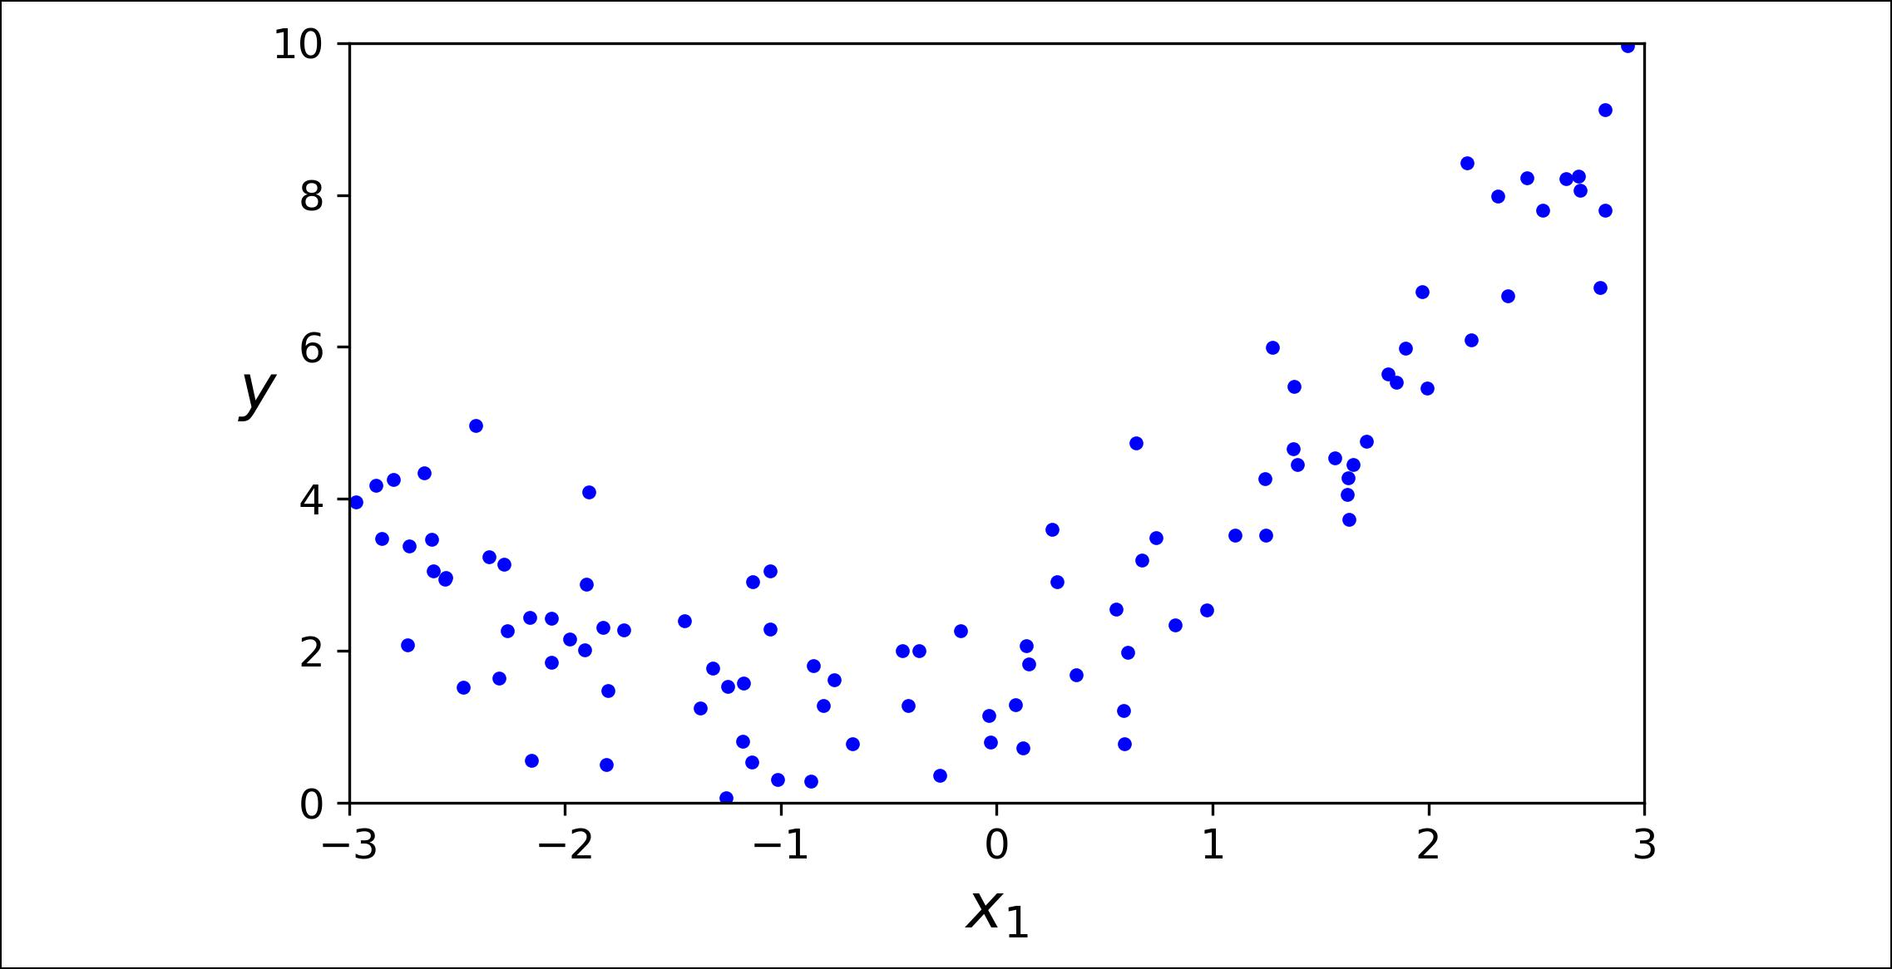

*Figure 4-12. Generated nonlinear and noisy dataset*

Clearly, a straight line will never fit this data properly. So let’s use Scikit-Learn’s Poly nomialFeatures class to transform our training data, adding the square (2nd-degree polynomial) of each feature in the training set as new features (in this case there is just one feature):

* **from sklearn.preprocessing import** PolynomialFeatures
* poly_features = PolynomialFeatures(degree=2, include_bias=False)
* X_poly = poly_features.fit_transform(X)
* X[0]

array([-0.75275929])

**>>>** X_poly[0]array([-0.75275929, 0.56664654])

X_poly now contains the original feature of X plus the square of this feature. Now you can fit a LinearRegression model to this extended training data (Figure 4-13):

* lin_reg = LinearRegression()
* lin_reg.fit(X_poly, y)
* lin_reg.intercept_, lin_reg.coef_ (array([1.78134581]), array([[0.93366893, 0.56456263]]))



**Polynomial Regression** **|** **131**

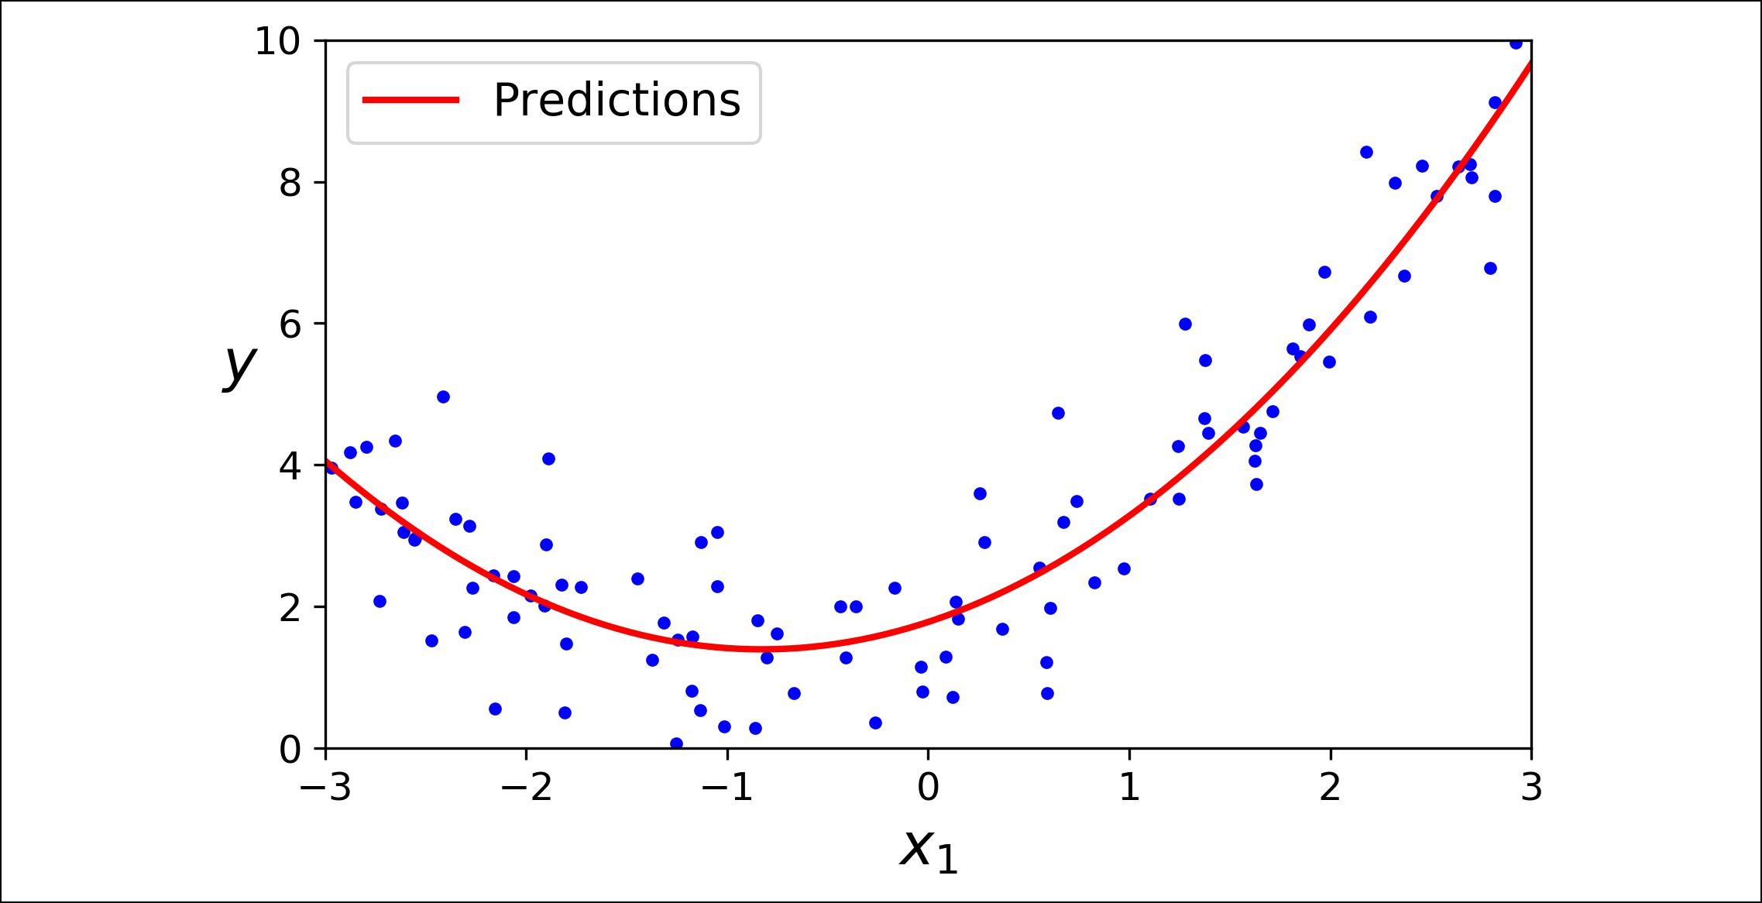

*Figure 4-13. Polynomial Regression model predictions*

Not bad: the model estimates *y* = 0 . 56*x*21 + 0 . 93*x*1 + 1 . 78 when in fact the original function was *y* = 0 . 5*x*21 + 1 . 0*x*1 + 2 . 0 + Gaussian noise.

Note that when there are multiple features, Polynomial Regression is capable of find‐ ing relationships between features (which is something a plain Linear Regression model cannot do). This is made possible by the fact that PolynomialFeatures also adds all combinations of features up to the given degree. For example, if there were two features *a* and *b*, PolynomialFeatures with degree=3 would not only add the features *a*2, *a*3, *b*2, and *b*3, but also the combinations *ab*, *a*2*b*, and *ab*2.

PolynomialFeatures(degree=d) transforms an array containing *n*

|  |  |  |  |
| --- | --- | --- | --- |
| features into an array containing | *n* + *d* ! | features, where *n*! is the |  |
| *d*! *n*! |  |
|  |  |  |

*factorial* of *n*, equal to 1 × 2 × 3 ×⋯× *n*. Beware of the combinato‐rial explosion of the number of features!

**Learning Curves**

If you perform high-degree Polynomial Regression, you will likely fit the training data much better than with plain Linear Regression. For example, Figure 4-14 applies a 300-degree polynomial model to the preceding training data, and compares the result with a pure linear model and a quadratic model (2nd-degree polynomial). Notice how the 300-degree polynomial model wiggles around to get as close as possi‐ ble to the training instances.



**132** **|** **Chapter 4: Training Models**

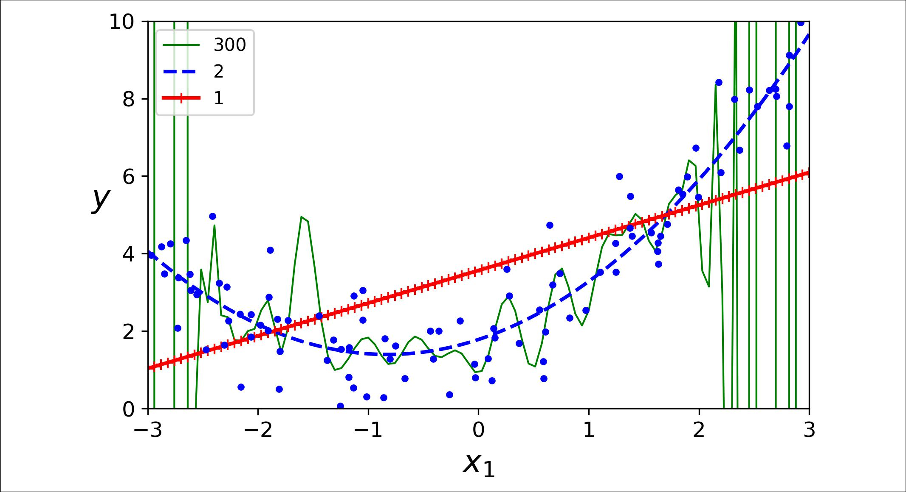

*Figure 4-14. High-degree Polynomial Regression*

Of course, this high-degree Polynomial Regression model is severely overfitting the training data, while the linear model is underfitting it. The model that will generalize best in this case is the quadratic model. It makes sense since the data was generated using a quadratic model, but in general you won’t know what function generated the data, so how can you decide how complex your model should be? How can you tell that your model is overfitting or underfitting the data?

In Chapter 2 you used cross-validation to get an estimate of a model’s generalization performance. If a model performs well on the training data but generalizes poorly according to the cross-validation metrics, then your model is overfitting. If it per‐ forms poorly on both, then it is underfitting. This is one way to tell when a model is too simple or too complex.

Another way is to look at the *learning curves*: these are plots of the model’s perfor‐ mance on the training set and the validation set as a function of the training set size (or the training iteration). To generate the plots, simply train the model several times on different sized subsets of the training set. The following code defines a function that plots the learning curves of a model given some training data:

**from sklearn.metrics import** mean_squared_error

**from sklearn.model_selection import** train_test_split

**def** plot_learning_curves(model,X,y):

X_train, X_val, y_train, y_val = train_test_split(X, y, test_size=0.2) train_errors, val_errors = [], []

**for** m **in** range(1, len(X_train)): model.fit(X_train[:m], y_train[:m]) y_train_predict = model.predict(X_train[:m])



**Learning Curves** **|** **133**

y_val_predict = model.predict(X_val) train_errors.append(mean_squared_error(y_train[:m], y_train_predict)) val_errors.append(mean_squared_error(y_val, y_val_predict))

plt.plot(np.sqrt(train_errors), "r-+", linewidth=2, label="train") plt.plot(np.sqrt(val_errors), "b-", linewidth=3, label="val")

Let’s look at the learning curves of the plain Linear Regression model (a straight line; Figure 4-15):

lin_reg = LinearRegression() plot_learning_curves(lin_reg, X, y)

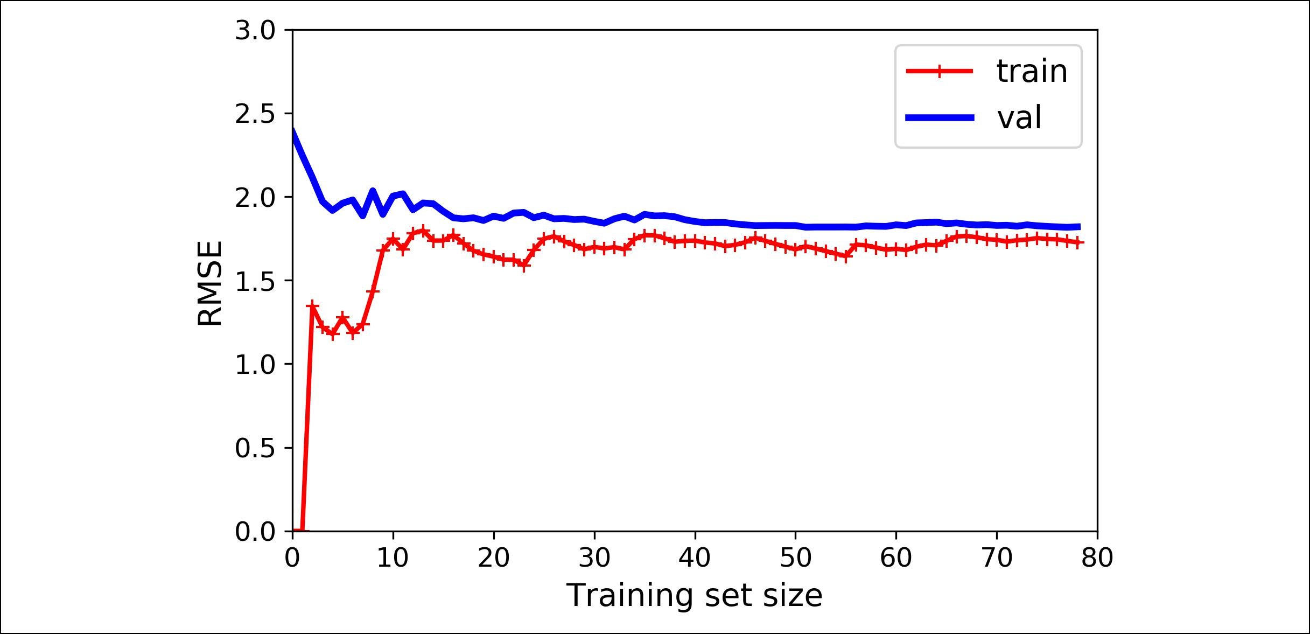

*Figure 4-15. Learning curves*

This deserves a bit of explanation. First, let’s look at the performance on the training data: when there are just one or two instances in the training set, the model can fit them perfectly, which is why the curve starts at zero. But as new instances are added to the training set, it becomes impossible for the model to fit the training data per‐ fectly, both because the data is noisy and because it is not linear at all. So the error on the training data goes up until it reaches a plateau, at which point adding new instan‐ ces to the training set doesn’t make the average error much better or worse. Now let’s look at the performance of the model on the validation data. When the model is trained on very few training instances, it is incapable of generalizing properly, which is why the validation error is initially quite big. Then as the model is shown more training examples, it learns and thus the validation error slowly goes down. However, once again a straight line cannot do a good job modeling the data, so the error ends up at a plateau, very close to the other curve.

These learning curves are typical of an underfitting model. Both curves have reached a plateau; they are close and fairly high.



**134** **|** **Chapter 4: Training Models**

If your model is underfitting the training data, adding more train‐ ing examples will not help. You need to use a more complex model or come up with better features.

Now let’s look at the learning curves of a 10th-degree polynomial model on the same data (Figure 4-16):

**from sklearn.pipeline import** Pipeline

polynomial_regression = Pipeline([

("poly_features", PolynomialFeatures(degree=10, include_bias=False)), ("lin_reg", LinearRegression()),

])

plot_learning_curves(polynomial_regression, X, y)

These learning curves look a bit like the previous ones, but there are two very impor‐ tant differences:

* The error on the training data is much lower than with the Linear Regression model.
* There is a gap between the curves. This means that the model performs signifi‐ cantly better on the training data than on the validation data, which is the hall‐ mark of an overfitting model. However, if you used a much larger training set, the two curves would continue to get closer.

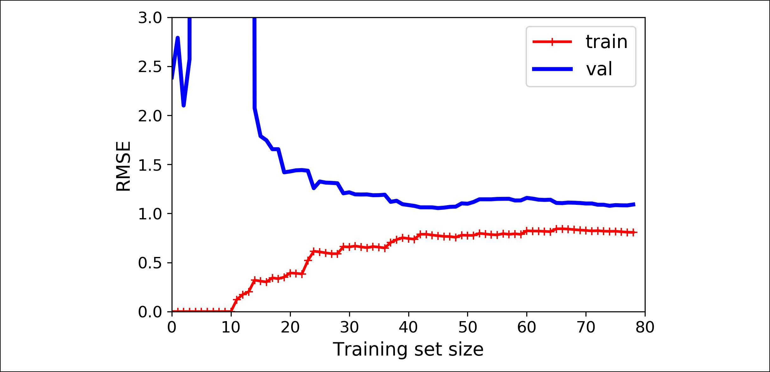

*Figure 4-16. Learning curves for the polynomial model*



**Learning Curves** **|** **135**

One way to improve an overfitting model is to feed it more training data until the validation error reaches the training error.



**The Bias/Variance Tradeoff**

An important theoretical result of statistics and Machine Learning is the fact that a model’s generalization error can be expressed as the sum of three very different errors:

*Bias*

This part of the generalization error is due to wrong assumptions, such as assum‐ ing that the data is linear when it is actually quadratic. A high-bias model is most likely to underfit the training data.10

*Variance*

This part is due to the model’s excessive sensitivity to small variations in the training data. A model with many degrees of freedom (such as a high-degree pol‐ ynomial model) is likely to have high variance, and thus to overfit the training data.

*Irreducible error*

This part is due to the noisiness of the data itself. The only way to reduce this part of the error is to clean up the data (e.g., fix the data sources, such as broken sensors, or detect and remove outliers).

Increasing a model’s complexity will typically increase its variance and reduce its bias. Conversely, reducing a model’s complexity increases its bias and reduces its variance. This is why it is called a tradeoff.

**Regularized Linear Models**

As we saw in Chapters 1 and 2, a good way to reduce overfitting is to regularize the model (i.e., to constrain it): the fewer degrees of freedom it has, the harder it will be for it to overfit the data. For example, a simple way to regularize a polynomial model is to reduce the number of polynomial degrees.

For a linear model, regularization is typically achieved by constraining the weights of the model. We will now look at Ridge Regression, Lasso Regression, and Elastic Net, which implement three different ways to constrain the weights.



10 This notion of bias is not to be confused with the bias term of linear models.



**136** **|** **Chapter 4: Training Models**

**Ridge Regression**

*Ridge Regression* (also called *Tikhonov regularization*) is a regularized version of Lin‐ear Regression: a *regularization term* equal to *α*∑*ni*= 1 *θi*2 is added to the cost function.

This forces the learning algorithm to not only fit the data but also keep the model weights as small as possible. Note that the regularization term should only be added to the cost function during training. Once the model is trained, you want to evaluate the model’s performance using the unregularized performance measure.

It is quite common for the cost function used during training to be different from the performance measure used for testing. Apart from regularization, another reason why they might be different is that a good training cost function should have optimization-friendly derivatives, while the performance measure used for test‐ ing should be as close as possible to the final objective. A good example of this is a classifier trained using a cost function such as the log loss (discussed in a moment) but evaluated using precision/ recall.



The hyperparameter *α* controls how much you want to regularize the model. If *α* = 0 then Ridge Regression is just Linear Regression. If *α* is very large, then all weights end up very close to zero and the result is a flat line going through the data’s mean. Equa‐ tion 4-8 presents the Ridge Regression cost function.11

*Equation 4-8. Ridge Regression cost function*

*J***θ** = MSE**θ** + *α* 12 ∑*ni*= 1 *θi*2

Note that the bias term *θ*0 is not regularized (the sum starts at *i* = 1, not 0). If we define **w** as the vector of feature weights (*θ*1 to *θn*), then the regularization term is simply equal to ½(∥ **w** ∥2)2, where ∥ **w** ∥2 represents the ℓ2 norm of the weight vector.12 For Gradient Descent, just add *α***w** to the MSE gradient vector (Equation 4-6).

It is important to scale the data (e.g., using a StandardScaler) before performing Ridge Regression, as it is sensitive to the scale of the input features. This is true of most regularized models.



1. It is common to use the notation *J*(**θ**) for cost functions that don’t have a short name; we will often use this notation throughout the rest of this book. The context will make it clear which cost function is being dis‐ cussed.
2. Norms are discussed in Chapter 2.



**Regularized Linear Models** **|** **137**

Figure 4-17 shows several Ridge models trained on some linear data using different *α* value. On the left, plain Ridge models are used, leading to linear predictions. On the right, the data is first expanded using PolynomialFeatures(degree=10), then it is scaled using a StandardScaler, and finally the Ridge models are applied to the result‐ ing features: this is Polynomial Regression with Ridge regularization. Note how increasing *α* leads to flatter (i.e., less extreme, more reasonable) predictions; this reduces the model’s variance but increases its bias.

As with Linear Regression, we can perform Ridge Regression either by computing a closed-form equation or by performing Gradient Descent. The pros and cons are the same. Equation 4-9 shows the closed-form solution (where **A** is the (*n* + 1) × (*n* + 1) *identity matrix*13exceptwith a 0 in the top-left cell, corresponding to the bias term).

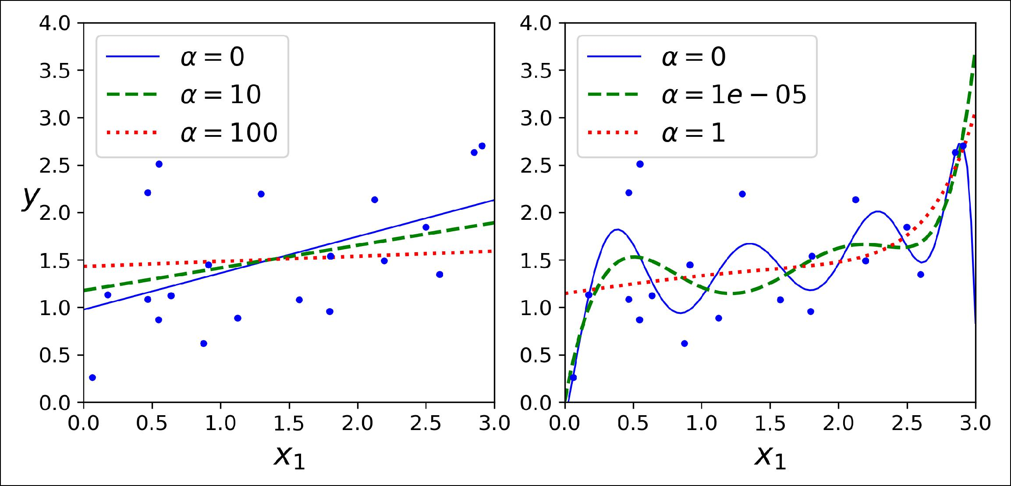

*Figure 4-17. Ridge Regression*

*Equation 4-9. Ridge Regression closed-form solution*

**θ** = **X***T***X** +*α***A**−1 **X***T* **y**



Here is how to perform Ridge Regression with Scikit-Learn using a closed-form solu‐ tion (a variant of Equation 4-9 using a matrix factorization technique by André-Louis Cholesky):

* **from sklearn.linear_model import** Ridge
* ridge_reg = Ridge(alpha=1, solver="cholesky")
* ridge_reg.fit(X, y)



13 A square matrix full of 0s except for 1s on the main diagonal (top-left to bottom-right).



**138** **|** **Chapter 4: Training Models**

**>>>** ridge_reg.predict([[1.5]])array([[1.55071465]])

And using Stochastic Gradient Descent:14

* sgd_reg = SGDRegressor(penalty="l2")
* sgd_reg.fit(X, y.ravel())
* sgd_reg.predict([[1.5]]) array([1.47012588])

The penalty hyperparameter sets the type of regularization term to use. Specifying "l2" indicates that you want SGD to add a regularization term to the cost function equal to half the square of the ℓ2 norm of the weight vector: this is simply Ridge Regression.

**Lasso Regression**

*Least Absolute Shrinkage and Selection Operator Regression* (simply called *Lasso Regression*) is another regularized version of Linear Regression: just like RidgeRegression, it adds a regularization term to the cost function, but it uses the ℓ1 norm of the weight vector instead of half the square of the ℓ2 norm (see Equation 4-10).

*Equation 4-10. Lasso Regression cost function*

*J***θ** = MSE**θ** + *α*∑*ni*= 1 *θi*

Figure 4-18 shows the same thing as Figure 4-17 but replaces Ridge models with Lasso models and uses smaller *α* values.



1. Alternatively you can use the Ridge class with the "sag" solver. Stochastic Average GD is a variant of SGD. For more details, see the presentation [“Minimizing Finite Sums with the Stochastic Average Gradient Algo‐](https://homl.info/12) [rithm”](https://homl.info/12) by Mark Schmidt et al. from the University of British Columbia.
2. 

**Regularized Linear Models** **|** **139**

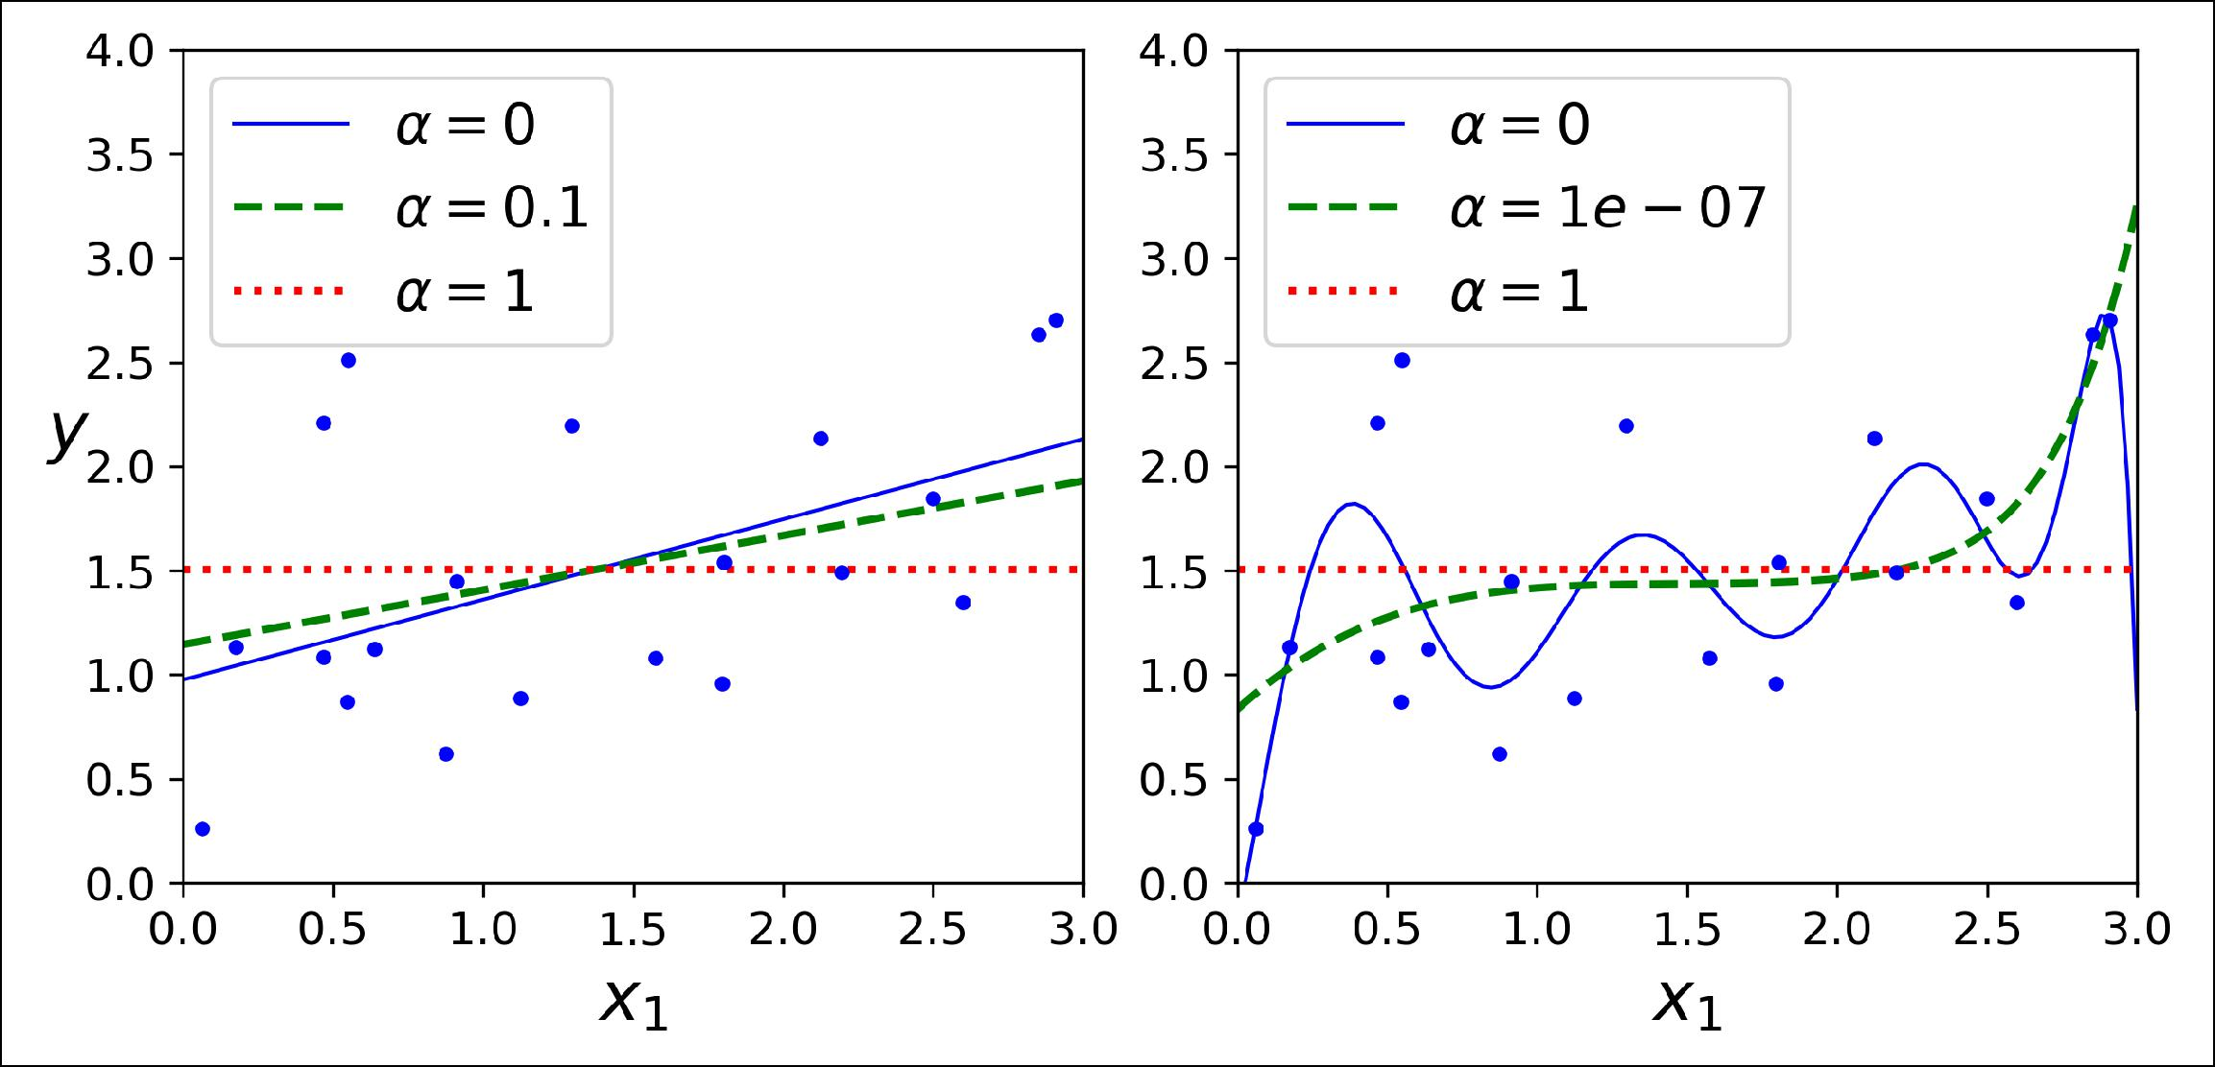

*Figure 4-18. Lasso Regression*

An important characteristic of Lasso Regression is that it tends to completely elimi‐ nate the weights of the least important features (i.e., set them to zero). For example, the dashed line in the right plot on Figure 4-18 (with *α* = 10-7) looks quadratic, almost linear: all the weights for the high-degree polynomial features are equal to zero. In other words, Lasso Regression automatically performs feature selection and outputs a *sparse model* (i.e., with few nonzero feature weights).

You can get a sense of why this is the case by looking at Figure 4-19: on the top-left plot, the background contours (ellipses) represent an unregularized MSE cost func‐ tion (*α* = 0), and the white circles show the Batch Gradient Descent path with that cost function. The foreground contours (diamonds) represent the ℓ1 penalty, and the triangles show the BGD path for this penalty only (*α* → ∞). Notice how the path first reaches *θ*1 = 0, then rolls down a gutter until it reaches *θ*2 = 0. On the top-right plot, the contours represent the same cost function plus an ℓ1 penalty with *α* = 0.5. The global minimum is on the *θ*2 = 0 axis. BGD first reaches *θ*2 = 0, then rolls down the gutter until it reaches the global minimum. The two bottom plots show the same thing but uses an ℓ2 penalty instead. The regularized minimum is closer to **θ** = **0** than the unregularized minimum, but the weights do not get fully eliminated.



**140** **|** **Chapter 4: Training Models**

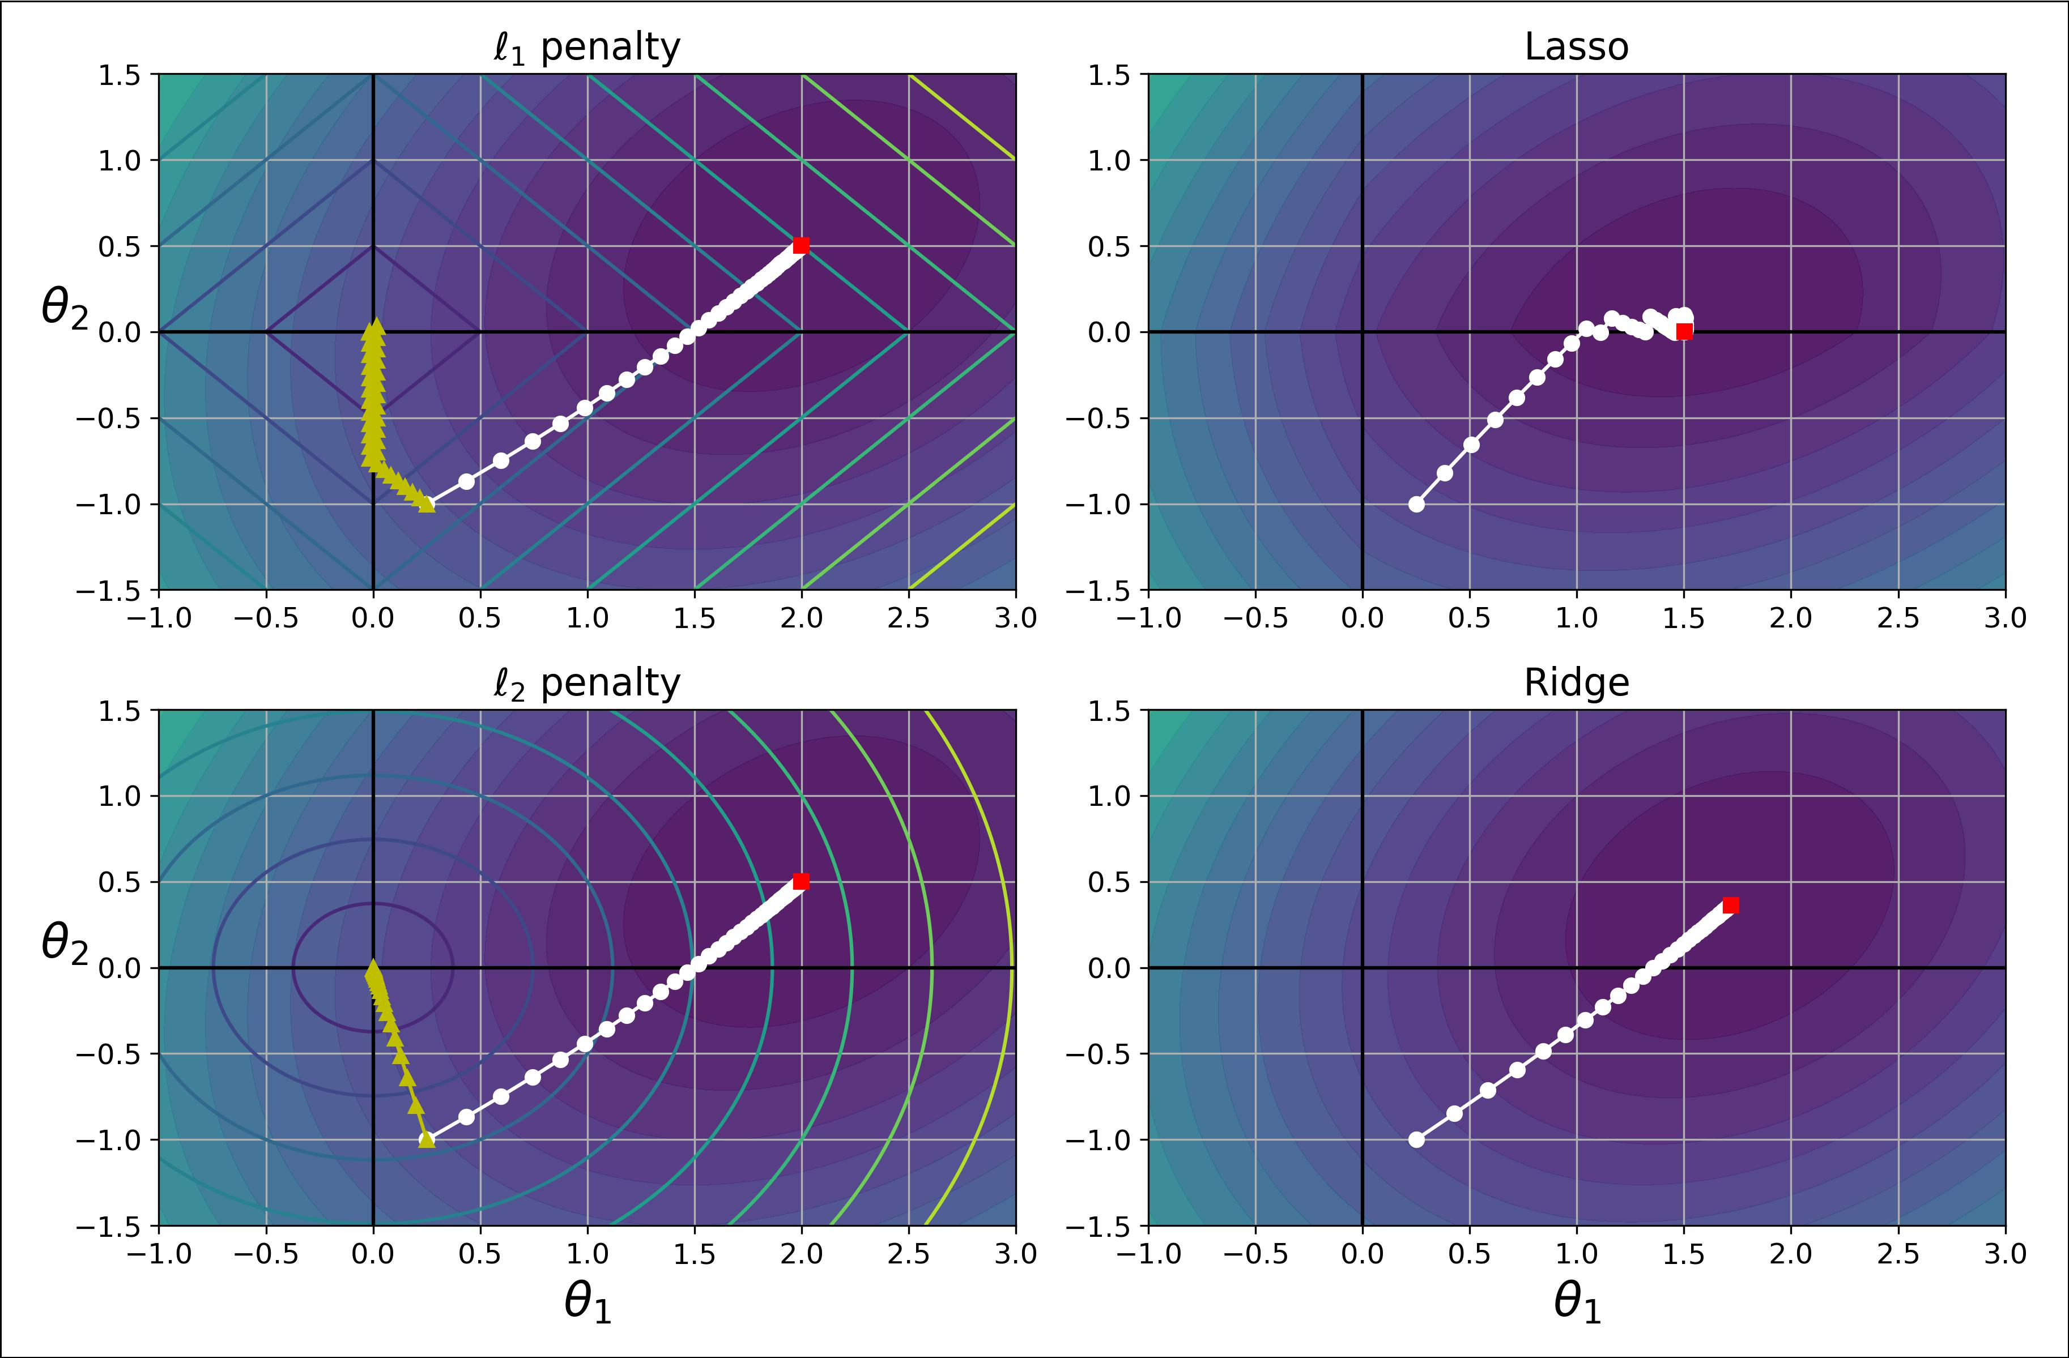

*Figure 4-19. Lasso versus Ridge regularization*



On the Lasso cost function, the BGD path tends to bounce across the gutter toward the end. This is because the slope changes abruptly at *θ*2 = 0. You need to gradually reduce the learning rate in order to actually converge to the global minimum.

The Lasso cost function is not differentiable at *θi* = 0 (for *i* = 1, 2, ⋯, *n*), but Gradient Descent still works fine if you use a *subgradient vector* **g**15 instead when any *θi* = 0. Equation 4-11 shows a subgradient vector equation you can use for Gradient Descent with the Lasso cost function.

*Equation 4-11. Lasso Regression subgradient vector*

|  |  |  |  |  |  |  |  |  |  |
| --- | --- | --- | --- | --- | --- | --- | --- | --- | --- |
|  |  |  | sign | *θ*1 |  |  |  | −1 if *θi* < 0 |  |
|  |  |  | sign | *θ*2 |  |  |  |  |
| *g* **θ**, *J* | = ∇**θ** MSE **θ** | + *α* | where sign | *θi* | = | 0 if *θi* = 0 |  |
| ⋮ |  |  |
|  |  |  |  |  |  |  | +1 if *θi* > 0 |  |
|  |  |  | sign | *θn* |  |  |  |  |
|  |  |  |  |  |  |  |  |



1. You can think of a subgradient vector at a nondifferentiable point as an intermediate vector between the gra‐ dient vectors around that point.



**Regularized Linear Models** **|** **141**

Here is a small Scikit-Learn example using the Lasso class. Note that you could instead use an SGDRegressor(penalty="l1").

* **from sklearn.linear_model import** Lasso
* lasso_reg = Lasso(alpha=0.1)
* lasso_reg.fit(X, y)
* lasso_reg.predict([[1.5]]) array([1.53788174])

**Elastic Net**

Elastic Net is a middle ground between Ridge Regression and Lasso Regression. The regularization term is a simple mix of both Ridge and Lasso’s regularization terms, and you can control the mix ratio *r*. When *r* = 0, Elastic Net is equivalent to Ridge Regression, and when *r* = 1, it is equivalent to Lasso Regression (see Equation 4-12).

*Equation 4-12. Elastic Net cost function*

*J***θ** = MSE**θ** + *rα*∑*ni*= 1 *θi* + 1 −2 *r* *α*∑*ni*= 1 *θi*2

So when should you use plain Linear Regression (i.e., without any regularization), Ridge, Lasso, or Elastic Net? It is almost always preferable to have at least a little bit of regularization, so generally you should avoid plain Linear Regression. Ridge is a good default, but if you suspect that only a few features are actually useful, you should pre‐ fer Lasso or Elastic Net since they tend to reduce the useless features’ weights down to zero as we have discussed. In general, Elastic Net is preferred over Lasso since Lasso may behave erratically when the number of features is greater than the number of training instances or when several features are strongly correlated.

Here is a short example using Scikit-Learn’s ElasticNet (l1_ratio corresponds to the mix ratio *r*):

* **from sklearn.linear_model import** ElasticNet
* elastic_net = ElasticNet(alpha=0.1, l1_ratio=0.5)
* elastic_net.fit(X, y)
* elastic_net.predict([[1.5]])

array([1.54333232])

**Early Stopping**

A very different way to regularize iterative learning algorithms such as Gradient Descent is to stop training as soon as the validation error reaches a minimum. This is called *early stopping*. Figure 4-20 shows a complex model (in this case a high-degree Polynomial Regression model) being trained using Batch Gradient Descent. As the epochs go by, the algorithm learns and its prediction error (RMSE) on the training set naturally goes down, and so does its prediction error on the validation set. However,



**142** **|** **Chapter 4: Training Models**

after a while the validation error stops decreasing and actually starts to go back up. This indicates that the model has started to overfit the training data. With early stop‐ ping you just stop training as soon as the validation error reaches the minimum. It is such a simple and efficient regularization technique that Geoffrey Hinton called it a “beautiful free lunch.”

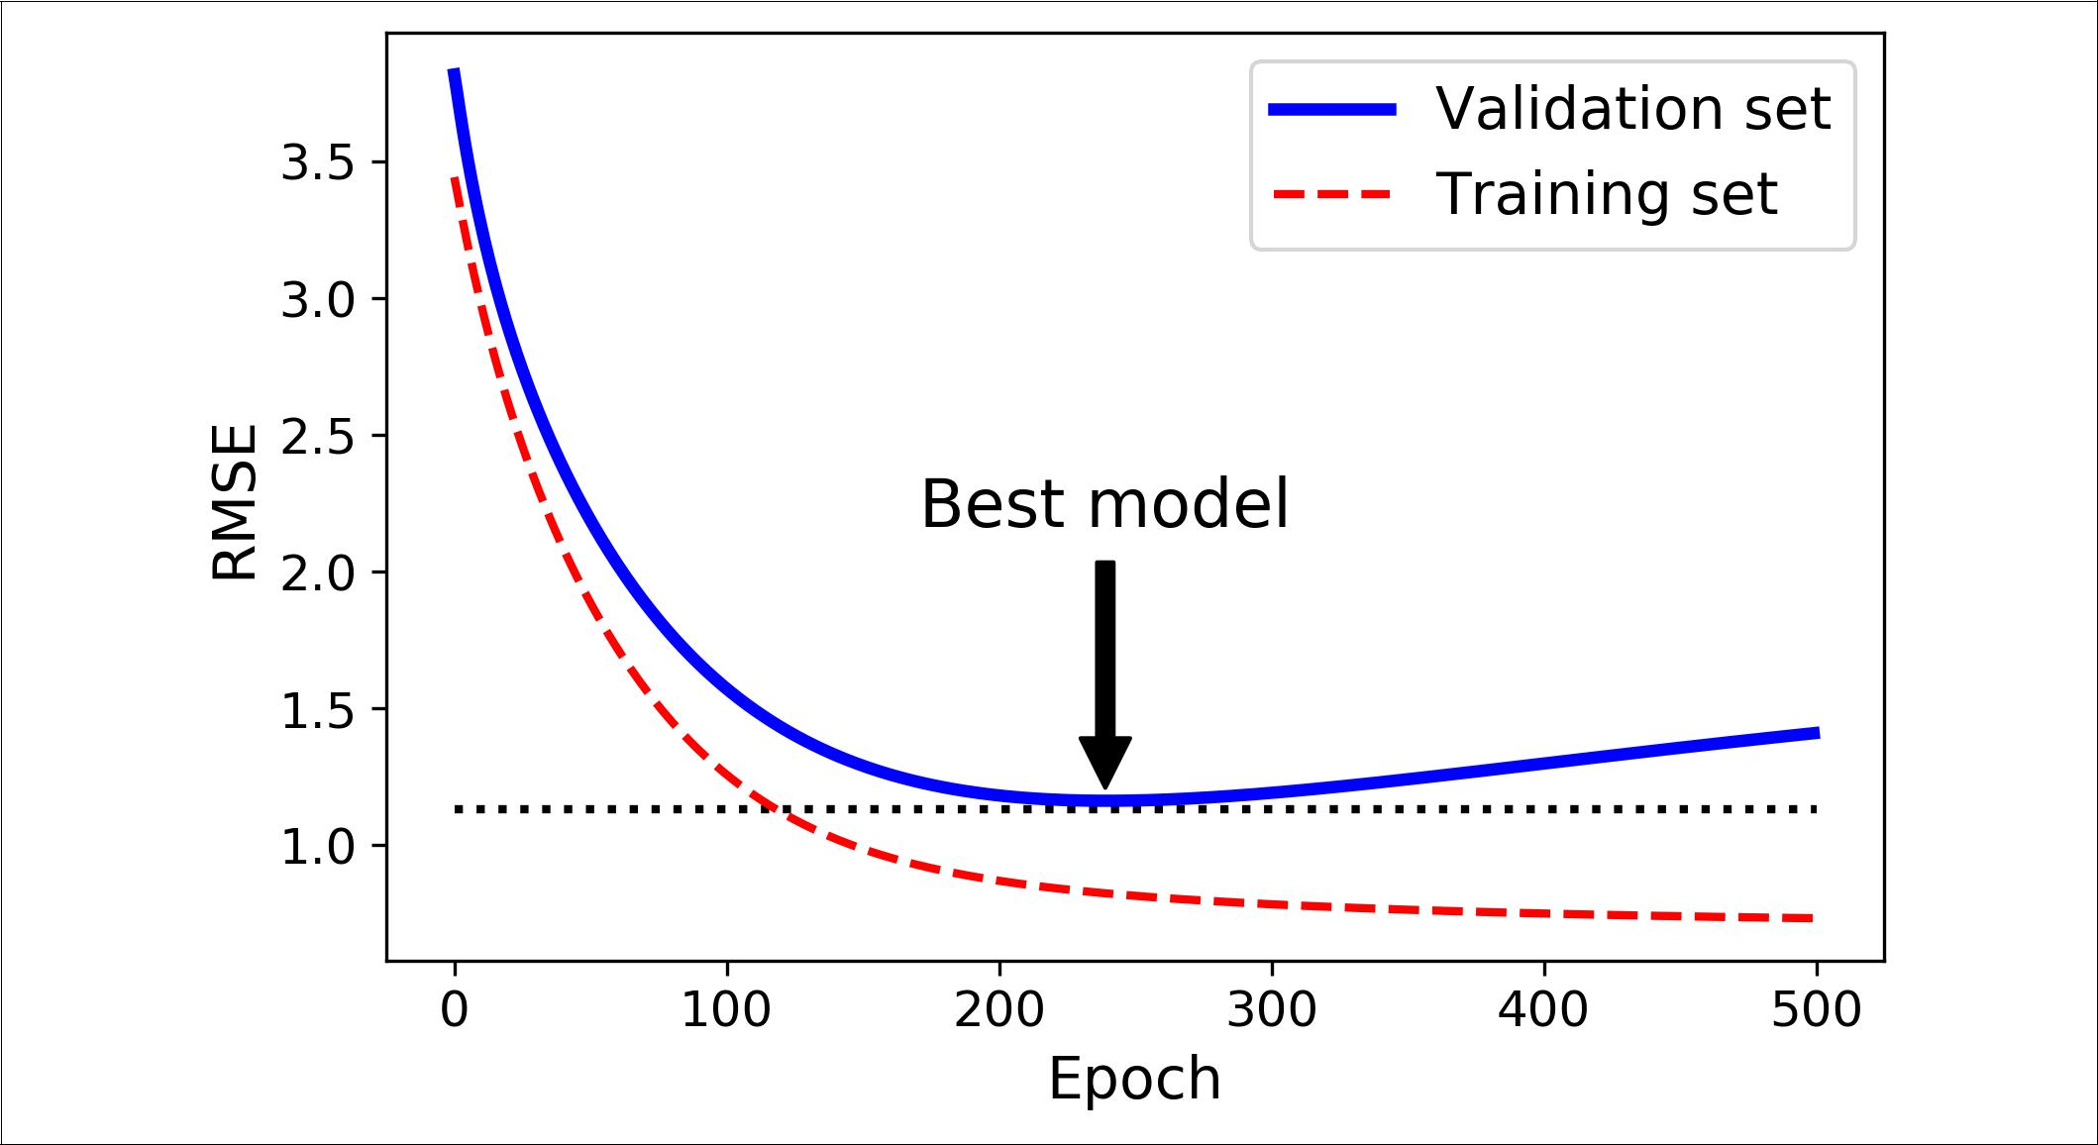

*Figure 4-20. Early stopping regularization*



With Stochastic and Mini-batch Gradient Descent, the curves are not so smooth, and it may be hard to know whether you have reached the minimum or not. One solution is to stop only after the validation error has been above the minimum for some time (when you are confident that the model will not do any better), then roll back the model parameters to the point where the validation error was at a minimum.

Here is a basic implementation of early stopping:

**from sklearn.base import** clone

*# prepare the data* poly_scaler = Pipeline([

("poly_features", PolynomialFeatures(degree=90, include_bias=False)), ("std_scaler", StandardScaler())

])

X_train_poly_scaled = poly_scaler.fit_transform(X_train) X_val_poly_scaled = poly_scaler.transform(X_val)

sgd_reg = SGDRegressor(max_iter=1, tol=-np.infty, warm_start=True, penalty=None, learning_rate="constant", eta0=0.0005)



**Regularized Linear Models** **|** **143**

minimum_val_error = float("inf") best_epoch = None

best_model = None

**for** epoch **in** range(1000):

sgd_reg.fit(X_train_poly_scaled, y_train) *# continues where it left off* y_val_predict = sgd_reg.predict(X_val_poly_scaled)

val_error = mean_squared_error(y_val, y_val_predict) **if** val_error<minimum_val_error:

minimum_val_error = val_error best_epoch = epoch best_model = clone(sgd_reg)

Note that with warm_start=True, when the fit() method is called, it just continues training where it left off instead of restarting from scratch.

**Logistic Regression**

As we discussed in Chapter 1, some regression algorithms can be used for classifica‐ tion as well (and vice versa). *Logistic Regression* (also called *Logit Regression*) is com‐ monly used to estimate the probability that an instance belongs to a particular class (e.g., what is the probability that this email is spam?). If the estimated probability is greater than 50%, then the model predicts that the instance belongs to that class (called the positive class, labeled “1”), or else it predicts that it does not (i.e., it belongs to the negative class, labeled “0”). This makes it a binary classifier.

**Estimating Probabilities**

So how does it work? Just like a Linear Regression model, a Logistic Regression model computes a weighted sum of the input features (plus a bias term), but instead of outputting the result directly like the Linear Regression model does, it outputs the *logistic* of this result (seeEquation 4-13).

*Equation 4-13. Logistic Regression model estimated probability (vectorized form) p* = *h***θ****x** = *σ***x***T***θ**

The logistic—noted *σ*(·)—is a *sigmoid function* (i.e., *S*-shaped) that outputs a number between 0 and 1. It is defined as shown in Equation 4-14 and Figure 4-21.

*Equation 4-14. Logistic function*

|  |  |  |  |
| --- | --- | --- | --- |
| *σ t* | = | 1 |  |
| 1 + exp − *t* |  |



**144** **|** **Chapter 4: Training Models**

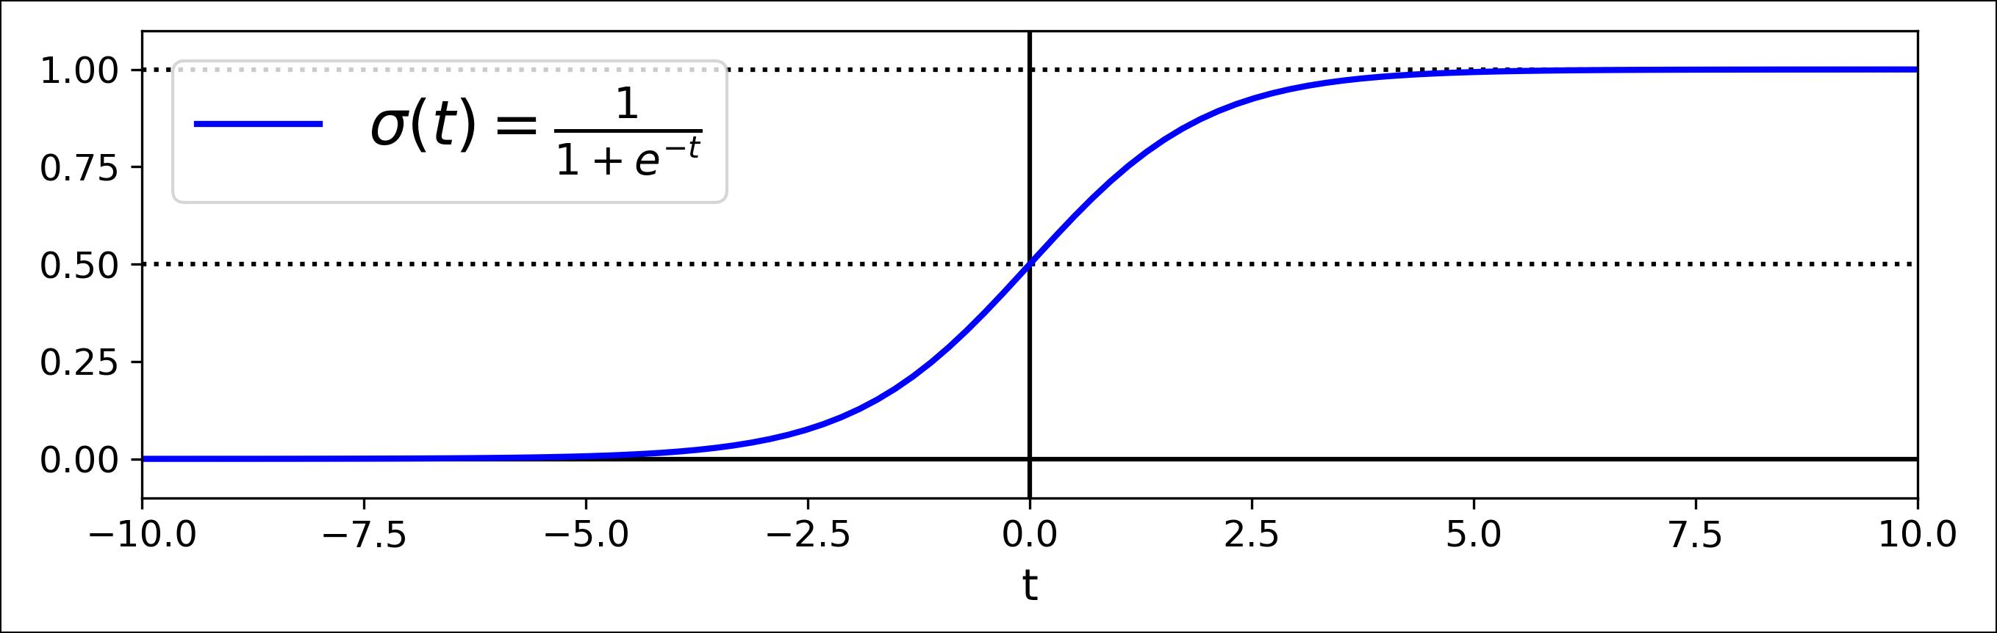

*Figure 4-21. Logistic function*

Once the Logistic Regression model has estimated the probability *p* = *h***θ**(**x**) that an instance **x** belongs to the positive class, it can make its prediction *ŷ* easily (see Equa‐ tion 4-15).

*Equation 4-15. Logistic Regression model prediction*

|  |  |  |  |
| --- | --- | --- | --- |
| *y* = | 0 | if | *p* < 0 . 5 |
|  | 1 | if | *p* ≥ 0 . 5 |



Notice that *σ*(*t*) < 0.5 when *t* < 0, and *σ*(*t*) ≥ 0.5 when *t* ≥ 0, so a Logistic Regression model predicts 1 if **x***T* **θ** is positive, and 0 if it is negative.

The score *t* is often called the *logit*: this name comes from the fact that the logit function, defined as logit(*p*) = log(*p* / (1 - *p*)), is the inverse of the logistic function. Indeed, if you compute the logit of the estimated probability *p*, you will find that the result is *t*. The logit is also called the *log-odds*, since it is the log of the ratio between the estimated probability for the positive class and the estimated probability for the negative class.



**Training and Cost Function**

Good, now you know how a Logistic Regression model estimates probabilities and makes predictions. But how is it trained? The objective of training is to set the param‐ eter vector **θ** so that the model estimates high probabilities for positive instances (*y* = 1) and low probabilities for negative instances (*y* = 0). This idea is captured by the cost function shown in Equation 4-16 for a single training instance **x**.

*Equation 4-16. Cost function of a single training instance*

|  |  |  |  |
| --- | --- | --- | --- |
| *c* **θ**= | −log *p* | if *y* = 1 |  |
| −log 1 − *p* | if *y* = 0 |  |



**Logistic Regression** **|** **145**

This cost function makes sense because – log(*t*) grows very large when *t* approaches 0, so the cost will be large if the model estimates a probability close to 0 for a positive instance, and it will also be very large if the model estimates a probability close to 1 for a negative instance. On the other hand, – log(*t*) is close to 0 when *t* is close to 1, so the cost will be close to 0 if the estimated probability is close to 0 for a negative instance or close to 1 for a positive instance, which is precisely what we want.

The cost function over the whole training set is simply the average cost over all train‐ ing instances. It can be written in a single expression (as you can verify easily), called the *log loss*, shown in Equation 4-17.

*Equation 4-17. Logistic Regression cost function (log loss)*

*J***θ** = − *m*1 ∑*mi*= 1 *y**i**log**p**i* + 1 − *y**i**log*1 − *p**i*

The bad news is that there is no known closed-form equation to compute the value of **θ** that minimizes this cost function (there is no equivalent of the Normal Equation).But the good news is that this cost function is convex, so Gradient Descent (or any other optimization algorithm) is guaranteed to find the global minimum (if the learn‐ ing rate is not too large and you wait long enough). The partial derivatives of the cost function with regards to the jth model parameter *θj* is given by Equation 4-18.

*Equation 4-18. Logistic cost function partial derivatives*

|  |  |  |  |  |  |  |
| --- | --- | --- | --- | --- | --- | --- |
| ∂ |  | 1 | *m* |  |  |  |
| J **θ** = | ∑ | *σ* **θ***T***x** *i* | − *y* *i* *xji* |  |
|  |  |  |
| ∂*θj* | | *m i* = 1 | | |  |  |

This equation looks very much like Equation 4-5: for each instance it computes the prediction error and multiplies it by the jth feature value, and then it computes the average over all training instances. Once you have the gradient vector containing all the partial derivatives you can use it in the Batch Gradient Descent algorithm. That’s it: you now know how to train a Logistic Regression model. For Stochastic GD you would of course just take one instance at a time, and for Mini-batch GD you would use a mini-batch at a time.

**Decision Boundaries**

Let’s use the iris dataset to illustrate Logistic Regression. This is a famous dataset that contains the sepal and petal length and width of 150 iris flowers of three different species: Iris-Setosa, Iris-Versicolor, and Iris-Virginica (see Figure 4-22).



**146** **|** **Chapter 4: Training Models**

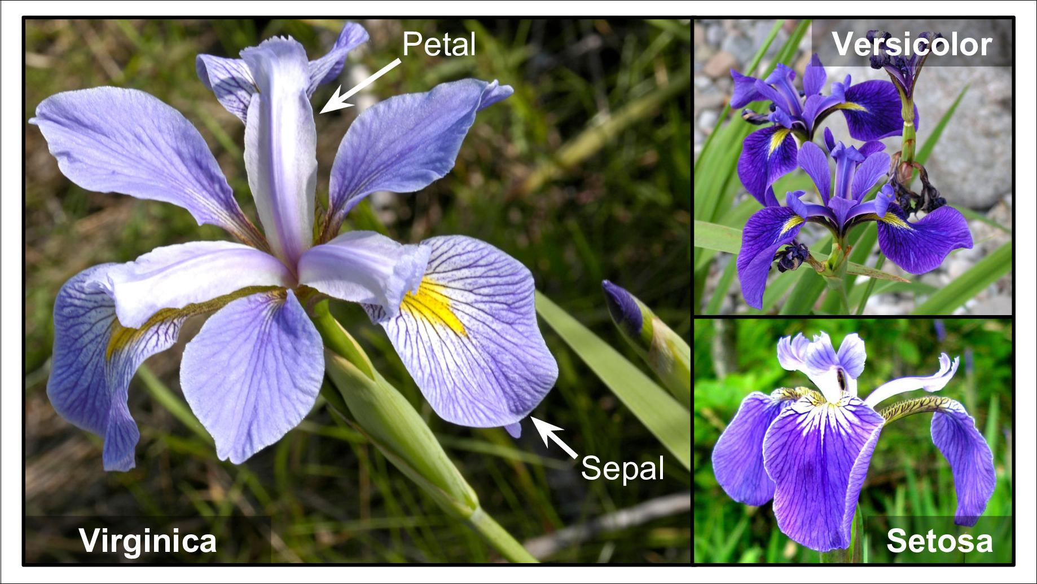

*Figure 4-22. Flowers of three iris plant species**16*

Let’s try to build a classifier to detect the Iris-Virginica type based only on the petal width feature. First let’s load the data:

* **from sklearn import** datasets
* iris = datasets.load_iris()
* list(iris.keys())

['data', 'target', 'target_names', 'DESCR', 'feature_names', 'filename']

* X = iris["data"][:, 3:] *# petal width*
* y = (iris["target"] == 2).astype(np.int) *# 1 if Iris-Virginica, else 0*

Now let’s train a Logistic Regression model:

**from sklearn.linear_model import** LogisticRegression

log_reg = LogisticRegression() log_reg.fit(X, y)

Let’s look at the model’s estimated probabilities for flowers with petal widths varying from 0 to 3 cm (Figure 4-23)17:

X_new = np.linspace(0, 3, 1000).reshape(-1, 1) y_proba = log_reg.predict_proba(X_new)

plt.plot(X_new, y_proba[:, 1], "g-", label="Iris-Virginica")



1. Photos reproduced from the corresponding Wikipedia pages. Iris-Virginica photo by Frank Mayfield ([Crea‐](https://creativecommons.org/licenses/by-sa/2.0/) [tive Commons BY-SA 2.0](https://creativecommons.org/licenses/by-sa/2.0/)), Iris-Versicolor photo by D. Gordon E. Robertson ([Creative Commons BY-SA 3.0](https://creativecommons.org/licenses/by-sa/3.0/)), and Iris-Setosa photo is public domain.
2. NumPy’s reshape() function allows one dimension to be –1, which means “unspecified”: the value is inferred from the length of the array and the remaining dimensions.
3. 

**Logistic Regression** **|** **147**

plt.plot(X_new, y_proba[:, 0], "b--", label="Not Iris-Virginica")

*# + more Matplotlib code to make the image look pretty*

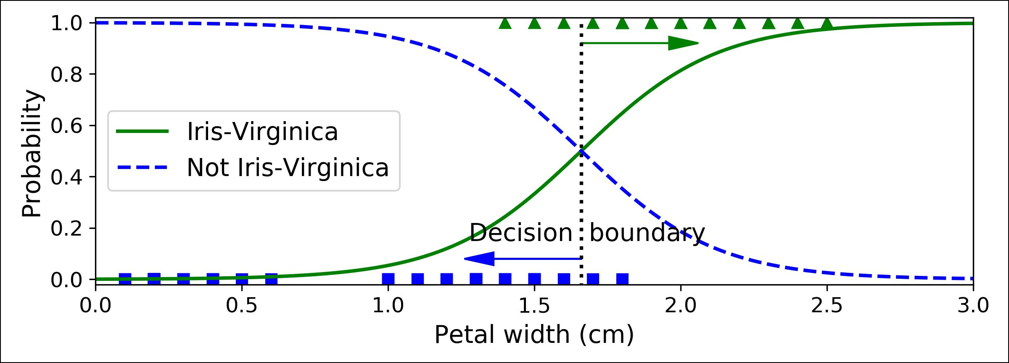

*Figure 4-23. Estimated probabilities and decision boundary*

The petal width of Iris-Virginica flowers (represented by triangles) ranges from 1.4 cm to 2.5 cm, while the other iris flowers (represented by squares) generally have a smaller petal width, ranging from 0.1 cm to 1.8 cm. Notice that there is a bit of over‐ lap. Above about 2 cm the classifier is highly confident that the flower is an Iris-Virginica (it outputs a high probability to that class), while below 1 cm it is highly confident that it is not an Iris-Virginica (high probability for the “Not Iris-Virginica” class). In between these extremes, the classifier is unsure. However, if you ask it to predict the class (using the predict() method rather than the predict_proba() method), it will return whichever class is the most likely. Therefore, there is a *decision* *boundary* at around 1.6 cm where both probabilities are equal to 50%: if the petalwidth is higher than 1.6 cm, the classifier will predict that the flower is an Iris-Virginica, or else it will predict that it is not (even if it is not very confident):

**>>>** log_reg.predict([[1.7], [1.5]])array([1, 0])

Figure 4-24 shows the same dataset but this time displaying two features: petal width and length. Once trained, the Logistic Regression classifier can estimate the probabil‐ ity that a new flower is an Iris-Virginica based on these two features. The dashed line represents the points where the model estimates a 50% probability: this is the model’s decision boundary. Note that it is a linear boundary.18 Each parallel line represents the points where the model outputs a specific probability, from 15% (bottom left) to 90% (top right). All the flowers beyond the top-right line have an over 90% chance of being Iris-Virginica according to the model.

18 It is the the set of points **x** such that *θ*0 + *θ*1*x*1 + *θ*2*x*2 = 0, which defines a straight line.



**148** **|** **Chapter 4: Training Models**

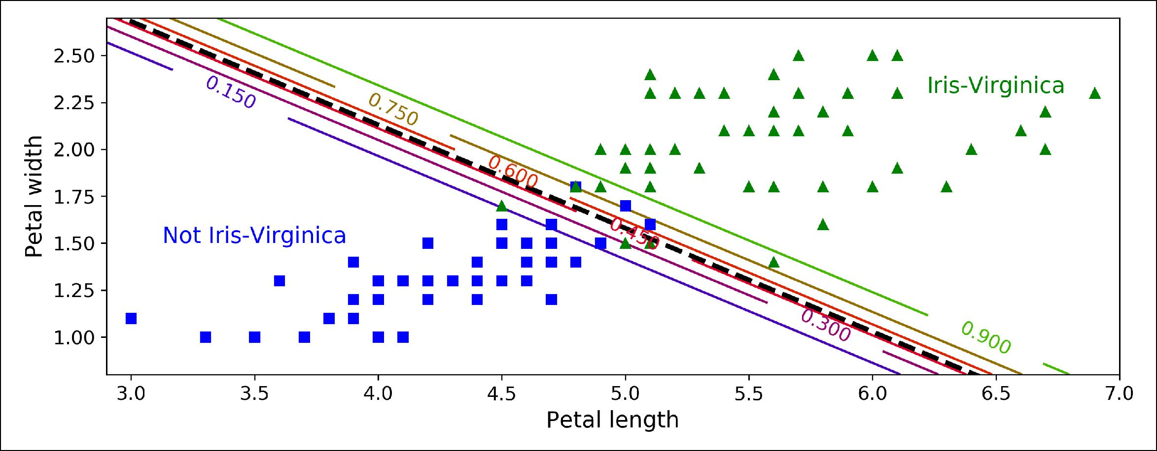

*Figure 4-24. Linear decision boundary*

Just like the other linear models, Logistic Regression models can be regularized using ℓ1 or ℓ2 penalties. Scitkit-Learn actually adds an ℓ2 penalty by default.

The hyperparameter controlling the regularization strength of a Scikit-Learn LogisticRegression model is not alpha (as in other linear models), but its inverse: C. The higher the value of C, the *less* the model is regularized.



**Softmax Regression**

The Logistic Regression model can be generalized to support multiple classes directly, without having to train and combine multiple binary classifiers (as discussed in Chapter 3). This is called *So•max Regression*, or *Multinomial Logistic Regression*.

The idea is quite simple: when given an instance **x**, the Softmax Regression model first computes a score *sk*(**x**) for each class *k*, then estimates the probability of each class by applying the *so•max function* (also called the *normalized exponential*) to the scores. The equation to compute *sk*(**x**) should look familiar, as it is just like the equa‐ tion for Linear Regression prediction (see Equation 4-19).

*Equation 4-19. So•max score for class k*

*sk***x** = **x***T***θ***k*

Note that each class has its own dedicated parameter vector **θ***(k)*. All these vectors are typically stored as rows in a *parameter matrix* **Θ**.

Once you have computed the score of every class for the instance **x**, you can estimate the probability *pk* that the instance belongs to class *k* by running the scores through the softmax function (Equation 4-20): it computes the exponential of every score,



**Logistic Regression** **|** **149**

then normalizes them (dividing by the sum of all the exponentials). The scores are generally called logits or log-odds (although they are actually unnormalized log-odds).

*Equation 4-20. So•max function*

|  |  |  |  |  |  |  |
| --- | --- | --- | --- | --- | --- | --- |
| *pk* = *σ* **s x** *k* = |  | exp *sk* **x** | |  |  |  |
| ∑*K* | = 1 | exp *s* | *j* | **x** |  |
|  | *j* |  |  |  |

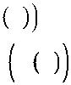

* *K* is the number of classes.
* **s**(**x**) is a vector containing the scores of each class for the instance **x**.
* *σ*(**s**(**x**))*k* is the estimated probability that the instance**x**belongs to class *k* giventhe scores of each class for that instance.

Just like the Logistic Regression classifier, the Softmax Regression classifier predicts the class with the highest estimated probability (which is simply the class with the highest score), as shown in Equation 4-21.

*Equation 4-21. So•max Regression classifier prediction*

|  |  |  |  |  |  |
| --- | --- | --- | --- | --- | --- |
| *y* = argmax *σ* **s x** | *k* | = argmax *s* | *k* | **x** = argmax **θ** *k T***x** |  |
| *k* | *k* | *k* |  |
|  |  |  |



* The *argmax* operator returns the value of a variable that maximizes a function. In this equation, it returns the value of *k* that maximizes the estimated probability *σ*(**s**(**x**))*k*.



The Softmax Regression classifier predicts only one class at a time (i.e., it is multiclass, not multioutput) so it should be used only with mutually exclusive classes such as different types of plants. You cannot use it to recognize multiple people in one picture.

Now that you know how the model estimates probabilities and makes predictions, let’s take a look at training. The objective is to have a model that estimates a high probability for the target class (and consequently a low probability for the other classes). Minimizing the cost function shown in Equation 4-22, called the *cross* *entropy*, should lead to this objective because it penalizes the model when it estimatesa low probability for a target class. Cross entropy is frequently used to measure how



**150** **|** **Chapter 4: Training Models**

well a set of estimated class probabilities match the target classes (we will use it again several times in the following chapters).

*Equation 4-22. Cross entropy cost function*

*J***Θ** = − *m*1 ∑*mi*= 1 ∑*Kk*= 1 *yki*log*pki*



* *yki* is the target probability that the ith instance belongs to class *k*. In general, it is either equal to 1 or 0, depending on whether the instance belongs to the class or not.

Notice that when there are just two classes (*K* = 2), this cost function is equivalent to the Logistic Regression’s cost function (log loss; see Equation 4-17).

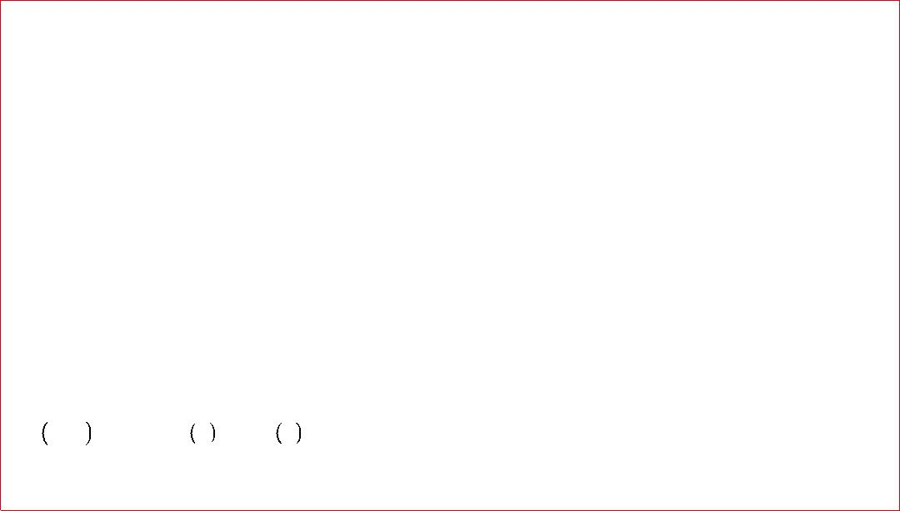

**Cross Entropy**

Cross entropy originated from information theory. Suppose you want to efficiently transmit information about the weather every day. If there are eight options (sunny, rainy, etc.), you could encode each option using 3 bits since 23 = 8. However, if you think it will be sunny almost every day, it would be much more efficient to code “sunny” on just one bit (0) and the other seven options on 4 bits (starting with a 1). Cross entropy measures the average number of bits you actually send per option. If your assumption about the weather is perfect, cross entropy will just be equal to the entropy of the weather itself (i.e., its intrinsic unpredictability). But if your assump‐ tions are wrong (e.g., if it rains often), cross entropy will be greater by an amount called the *Kullback–Leibler divergence*.

|  |  |  |  |
| --- | --- | --- | --- |
| The cross | entropy | between | two probability distributions *p* and *q* is defined as |
| *H p*, *q* = | − ∑*x* *p x* | log *q x* | (at least when the distributions are discrete). For more |

details, check out [this video](https://homl.info/xentropy).

The gradient vector of this cost function with regards to **θ***(k)* is given by Equation 4-23:

*Equation 4-23. Cross entropy gradient vector for class k*

∇ *J* **Θ** = 1 *m* *p* *i* − *y* *i* **x** *i* **θ** *k**m**i*∑=1*k**k*



Now you can compute the gradient vector for every class, then use Gradient Descent (or any other optimization algorithm) to find the parameter matrix **Θ** that minimizes the cost function.



**Logistic Regression** **|** **151**

Let’s use Softmax Regression to classify the iris flowers into all three classes. Scikit-Learn’s LogisticRegression uses one-versus-all by default when you train it on more than two classes, but you can set the multi_class hyperparameter to "multinomial" to switch it to Softmax Regression instead. You must also specify a solver that sup‐ ports Softmax Regression, such as the "lbfgs" solver (see Scikit-Learn’s documenta‐ tion for more details). It also applies ℓ2 regularization by default, which you can control using the hyperparameter C.

X = iris["data"][:, (2, 3)] *# petal length, petal width* y = iris["target"]

softmax_reg = LogisticRegression(multi_class="multinomial",solver="lbfgs", C=10) softmax_reg.fit(X, y)

So the next time you find an iris with 5 cm long and 2 cm wide petals, you can ask your model to tell you what type of iris it is, and it will answer Iris-Virginica (class 2) with 94.2% probability (or Iris-Versicolor with 5.8% probability):

* softmax_reg.predict([[5, 2]]) array([2])
* softmax_reg.predict_proba([[5, 2]]) array([[6.38014896e-07, 5.74929995e-02, 9.42506362e-01]])

Figure 4-25 shows the resulting decision boundaries, represented by the background colors. Notice that the decision boundaries between any two classes are linear. The figure also shows the probabilities for the Iris-Versicolor class, represented by the curved lines (e.g., the line labeled with 0.450 represents the 45% probability bound‐ ary). Notice that the model can predict a class that has an estimated probability below 50%. For example, at the point where all decision boundaries meet, all classes have an equal estimated probability of 33%.

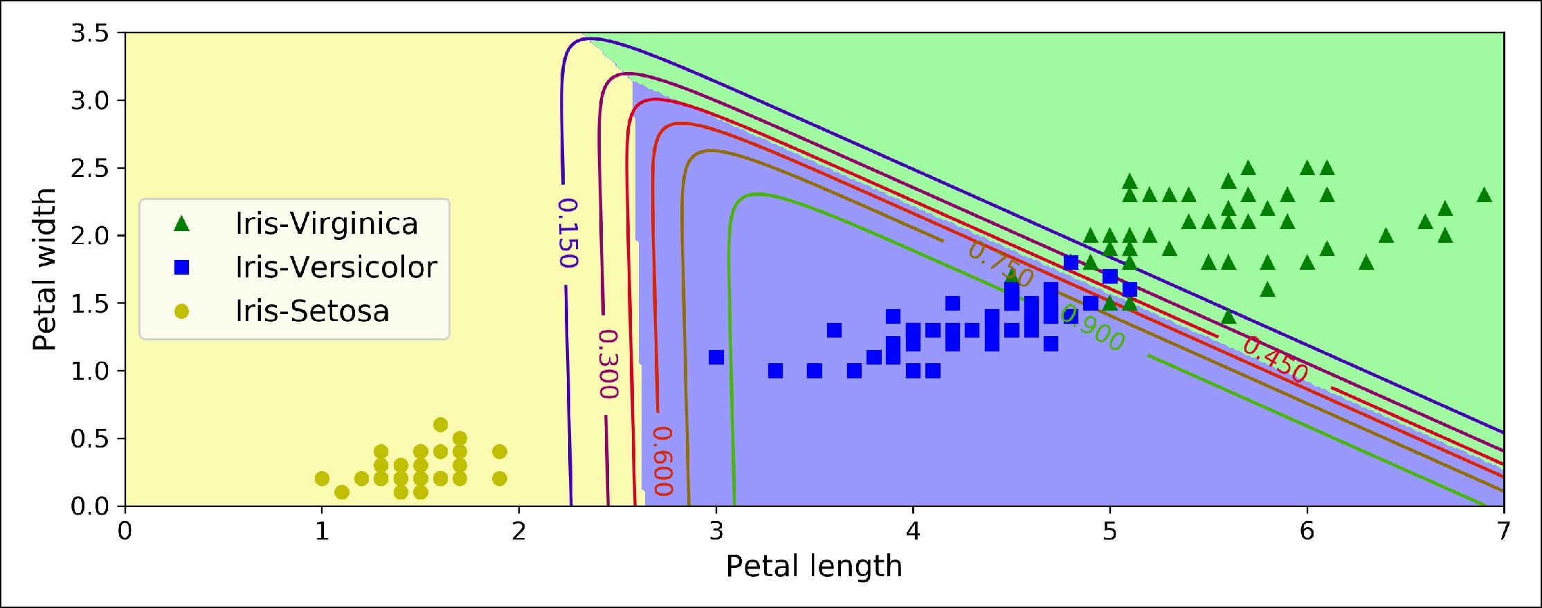

*Figure 4-25. So•max Regression decision boundaries*



**152** **|** **Chapter 4: Training Models**

**Exercises**

1. What Linear Regression training algorithm can you use if you have a training set with millions of features?
2. Suppose the features in your training set have very different scales. What algo‐ rithms might suffer from this, and how? What can you do about it?
3. Can Gradient Descent get stuck in a local minimum when training a Logistic Regression model?
4. Do all Gradient Descent algorithms lead to the same model provided you let them run long enough?
5. Suppose you use Batch Gradient Descent and you plot the validation error at every epoch. If you notice that the validation error consistently goes up, what is likely going on? How can you fix this?
6. Is it a good idea to stop Mini-batch Gradient Descent immediately when the vali‐ dation error goes up?
7. Which Gradient Descent algorithm (among those we discussed) will reach the vicinity of the optimal solution the fastest? Which will actually converge? How can you make the others converge as well?
8. Suppose you are using Polynomial Regression. You plot the learning curves and you notice that there is a large gap between the training error and the validation error. What is happening? What are three ways to solve this?
9. Suppose you are using Ridge Regression and you notice that the training error and the validation error are almost equal and fairly high. Would you say that the model suffers from high bias or high variance? Should you increase the regulari‐ zation hyperparameter *α* or reduce it?
10. Why would you want to use:
    * Ridge Regression instead of plain Linear Regression (i.e., without any regulari‐ zation)?
    * Lasso instead of Ridge Regression?
    * Elastic Net instead of Lasso?
11. Suppose you want to classify pictures as outdoor/indoor and daytime/nighttime. Should you implement two Logistic Regression classifiers or one Softmax Regres‐ sion classifier?
12. Implement Batch Gradient Descent with early stopping for Softmax Regression (without using Scikit-Learn).

Solutions to these exercises are available in ???.



**Exercises** **|** **153**